Emmanuel Rosario
COMP IV: Project Portfolio
Fall 2016

Contents:

PS0 Hello World with SFML
PS1 Recursive Graphic
PS2 Linear Feedback Shift Register and Image Encoding
PS3 N-Body Simulation
PS4 Edit Distance
PS5 Ring Buffer and Guitar Hero
PS6 Markov Model of Natural Language
PS7 Kronos Intouch Parsing

PS0 Hello World with SFML

Summary:
The assignment PS0 was to get us started with SFML libraries. Parts of this assignment was to draw an image sprite, and make the image move around the screen using the arrow keys. In addition, I made my program to allow the user to capture and save screen shot as my something else with was part of the assignment.
Data Structures/Algorithms:
This assignment just used the SFML window, sf, sprites and textures.

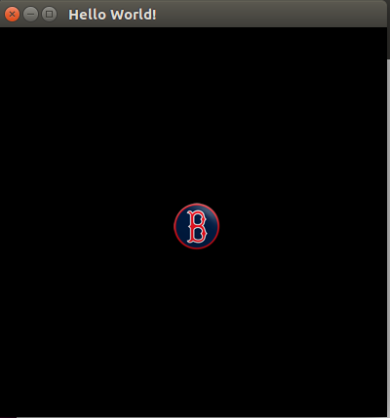

main.cpp:

- #include <SFML/Graphics.hpp>
- #include <iostream>
- #include <string>
- using namespace std;

- int main()
- {
- //setting window up
- sf::RenderWindow window(sf::VideoMode(400, 400), "Hello World!");

- sf::Texture texture;

- // loading the image
- if (!texture.loadFromFile("sprite.png"))
- return EXIT_FAILURE;

- sf::Sprite sprite(texture);

- //set the starting position for the sprite
- sprite.setOrigin(-180,-180);

- cout <<"Press F7 for a screenshot,and to move the sprite use the arrow keys please."<<endl;

- while(window.isOpen())
- {
- sf::Event event;
- while (window.pollEvent(event))
- {
- // close window
- if (event.type == sf::Event::Closed)
- window.close();
- }

- //
- window.setFramerateLimit(60);

- //sprite respond to the keystrokess pressed

- // move when the right key is pressed
- if (sf::Keyboard::isKeyPressed(sf::Keyboard::Right))
- {
- sprite.move(1,0);
- }

- // move when the left key is pressed
- if (sf::Keyboard::isKeyPressed(sf::Keyboard::Left))
- {
- sprite.move(-1,0);
- }

- // move when the down key is pressed
- if (sf::Keyboard::isKeyPressed(sf::Keyboard::Down))
- {
- sprite.move(0,1);
- }

- // move when the up key is pressed
- if (sf::Keyboard::isKeyPressed(sf::Keyboard::Up))
- {
- sprite.move(0,-1);
- }

- // to take a screenshot and saved it as well.
- if (sf::Keyboard::isKeyPressed(sf::Keyboard::F7))
- {
- sf::Image Screen = window.capture();
- Screen.saveToFile("windowscreenshot.png");
- }

- //clear the window and changed background color to red
- window.clear(sf::Color(200, 0, 0));

- //draw the sprite
- window.draw(sprite);

- //update the window
- window.display();
- }

- return 0;
- }

PS1 Recursive Graphics (Sierpinski's Triangle)

Summary:
The assignment PS1 was to implement a drawable interface using recursion. For this assignment we had to make two projects: one was the Sierpinski implementation and the other one was our own original work using recursive. At first, I didn’t know how to implement this assignment, but once I got to understand sfml better, I finished it as my PSX. When I did my own original, I implement the same code as the sierpinski’s triangle but I add it out line thickness so I can make a unique shape.
Data Structures/Algorithms:
This assignment was to use recursion to make a Sierpinski’s triangle.

Sierpinski’s Triangle

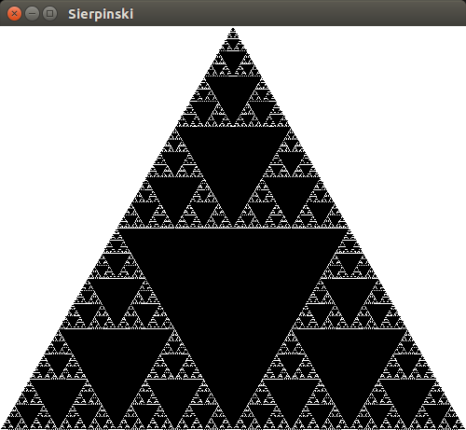

Original Shape
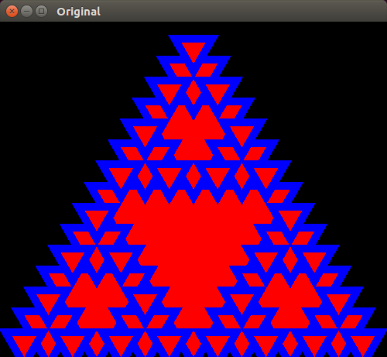

Makefile
- CC = g++
- CFLAGS = -Wall -ansi -pedantic -Werror -std=c++0x -lboost_unit_test_framework
- LFLAGS = -lsfml-window -lsfml-graphics -lsfml-audio -lsfml-system

- all: sierpinski original

- sierpinski: main.o sierpinski.o
- $(CC) main.o sierpinski.o $(CFLAGS) $(LFLAGS) -o sierpinski

- original: maino.o original.o
- $(CC) maino.o original.o $(CFLAGS) $(LFLAGS) -o original

- main.o: main.cpp sierpinski.hpp
- $(CC) -c $(CFLAGS) $(LFLAGS) main.cpp

- sierpinski.o: sierpinski.cpp sierpinski.hpp
- $(CC) -c $(CFLAGS) $(LFLAGS) sierpinski.cpp

- maino.o: maino.cpp original.hpp
- $(CC) -c $(CFLAGS) $(LFLAGS) maino.cpp

- original.o: original.cpp original.hpp
- $(CC) -c $(CFLAGS) $(LFLAGS) original.cpp

- clean:
- rm *.o sierpinski original

main.cpp

- // Copyright 2016 Emmanuel Rosario
- #include <sstream>
- #include <string>
- #include <stdexcept>
- #include "sierpinski.hpp"

- using namespace std; //NOLINT

- int main(int argc, char* argv[]) {
- if (argc < 3) {
- std::cout << "You need to enter a depth and window size.";
- std::cout << "\nExample:\n\t./sierpinski <depth> <window width>";
- std::cout << "\n\t./Sierpinski 8 500\n";
- exit(1);
- }
- int depth, width;

- istringstream arg_depth(argv[1]);
- arg_depth >> depth;
- stringstream arg_width(argv[2]);
- arg_width >> width;

- if (depth < 0) {
- throw std::runtime_error(" depth needs to be greater than 0.");
- } else if (depth > 10) {
- throw std::runtime_error(" depth needs to be less than 10.");
- }

- if (width < 100) {
- throw std::runtime_error(" window size needs to be greater than 100.");
- }

- double height = (sqrt(3) / 2.0) * (double)width; //NOLINT
- sf::RenderWindow window(sf::VideoMode(width, height), "Sierpinski");
- window.setFramerateLimit(30);
- Sierpinski triangle_draw(depth, width);

- while (window.isOpen()) {
- sf::Event event;
- while (window.pollEvent(event)) {
- if (event.type == sf::Event::Closed) {
- window.close();
- break;
- }
- }
- window.clear(sf::Color::White);
- window.draw(triangle_draw);
- window.display();
- }
- return 0;
- } //NOLINT

sierpinski.hpp

- // Copyright 2016 Emmanuel Rosario
- #ifndef _HOME_EMMANUEL_DESKTOP_PS1_SIERPINSKI_HPP_
- #define _HOME_EMMANUEL_DESKTOP_PS1_SIERPINSKI_HPP_
- #include <cmath>
- #include <iostream>
- #include <SFML/Graphics.hpp>
- #include <SFML/Window.hpp>
- #include <vector> //NOLINT

- class Sierpinski : public sf::Drawable {
- public:
- Sierpinski(int depth, int width);
- sf::Vector2f mid(sf::Vector2f x, sf::Vector2f y);
- void makeTriangles(int depth, sf::Vector2f p1, sf::Vector2f p2,
- sf::Vector2f p3);
- void draw(sf::RenderTarget& target, sf::RenderStates states) const; //NOLINT
- private:
- int depth;
- int width;
- std::vector<sf::ConvexShape> triangles;
- };
- #endif // _HOME_EMMANUEL_DESKTOP_PS1_SIERPINSKI_HPP_

sierpinski.cpp

- // Copyright 2016 Emmanuel Rosario
- #include <iostream>
- #include <cmath>
- #include "original.hpp"

- Sierpinski::Sierpinski(int recursion_depth, int window_width) :
- depth(recursion_depth), width(window_width) {
- double height = (sqrt(3)/2.0) * double(width); //NOLINT
- sf::Vector2f left = sf::Vector2f(0, height);
- sf::Vector2f right = sf::Vector2f(width, height);
- sf::Vector2f middle = sf::Vector2f((width/2), 0);

- makeTriangles(depth, left, right, middle);
- }

- sf::Vector2f Sierpinski::mid(sf::Vector2f p1, sf::Vector2f p2) {
- return sf::Vector2f((p1.x + p2.x) / 2, (p1.y + p2.y) / 2);
- }

- void Sierpinski::makeTriangles(int depth, sf::Vector2f p1,
- sf::Vector2f p2, sf::Vector2f p3) {

- if (depth == 0) {
- return;
- } else {
- sf::Vector2f mid_1 = mid(p1, p2);
- sf::Vector2f mid_2 = mid(p2, p3);
- sf::Vector2f mid_3 = mid(p1, p3);

- sf::ConvexShape tri;
- tri.setPointCount(3);
- tri.setFillColor(sf::Color::Red);
- tri.setOutlineThickness(10.0f);
- tri.setOutlineColor(sf::Color::Blue);
- tri.setPoint(0, mid_1);
- tri.setPoint(1, mid_2);
- tri.setPoint(2, mid_3);
- triangles.push_back(tri);

- makeTriangles((depth-1), p1, mid_1, mid_3);
- makeTriangles((depth-1), mid_1, p2, mid_2);
- makeTriangles((depth-1), mid_3, mid_2, p3);
- }
- }

- void Sierpinski::draw(sf::RenderTarget& target, sf::RenderStates states) const {
- int num = triangles.size();
- for (int i = 0; i < num; i++)
- target.draw(triangles[i]);
- } // NOLINT

maino.cpp

- // Copyright 2016 Emmanuel Rosario
- #include <sstream>
- #include <string>
- #include <stdexcept>
- #include "sierpinski.hpp"

- using namespace std; //NOLINT

- int main(int argc, char* argv[]) {
- if (argc < 3) {
- std::cout << "You need to enter a depth and window size.";
- std::cout << "\nExample:\n\t./sierpinski <depth> <window width>";
- std::cout << "\n\t./Sierpinski 8 500\n";
- exit(1);
- }
- int depth, width;

- istringstream arg_depth(argv[1]);
- arg_depth >> depth;
- stringstream arg_width(argv[2]);
- arg_width >> width;

- if (depth < 0) {
- throw std::runtime_error(" depth needs to be greater than 0.");
- } else if (depth > 10) {
- throw std::runtime_error(" depth needs to be less than 10.");
- }

- if (width < 100) {
- throw std::runtime_error(" window size needs to be greater than 100.");
- }

- double height = (sqrt(3) / 2.0) * (double)width; //NOLINT
- sf::RenderWindow window(sf::VideoMode(width, height), "Original");
- window.setFramerateLimit(30);
- Sierpinski triangle_draw(depth, width);

- while (window.isOpen()) {
- sf::Event event;
- while (window.pollEvent(event)) {
- if (event.type == sf::Event::Closed) {
- window.close();
- break;
- }
- }
- window.clear(sf::Color::Black);
- window.draw(triangle_draw);
- window.display();
- }
- return 0;
- } //NOLINT

original.hpp

- // Copyright 2016 Emmanuel Rosario
- #ifndef _HOME_EMMANUEL_DESKTOP_PS1_ORIGINAL_HPP_
- #define _HOME_EMMANUEL_DESKTOP_PS1_ORIGINAL_HPP_
- #include <cmath>
- #include <iostream>
- #include <SFML/Graphics.hpp>
- #include <SFML/Window.hpp>
- #include <vector> //NOLINT

- class Sierpinski : public sf::Drawable {
- public:
- Sierpinski(int depth, int width);
- sf::Vector2f mid(sf::Vector2f x, sf::Vector2f y);
- void makeTriangles(int depth, sf::Vector2f p1, sf::Vector2f p2,
- sf::Vector2f p3);
- void draw(sf::RenderTarget& target, sf::RenderStates states) const; //NOLINT
- private:
- int depth;
- int width;
- std::vector<sf::ConvexShape> triangles;
- };
- #endif // _HOME_EMMANUEL_DESKTOP_PS1_ORIGINAL_HPP_

original.cpp

- // Copyright 2016 Emmanuel Rosario
- #include <iostream>
- #include <cmath>
- #include "original.hpp"

- Sierpinski::Sierpinski(int recursion_depth, int window_width) :
- depth(recursion_depth), width(window_width) {
- double height = (sqrt(3)/2.0) * double(width); //NOLINT
- sf::Vector2f left = sf::Vector2f(0, height);
- sf::Vector2f right = sf::Vector2f(width, height);
- sf::Vector2f middle = sf::Vector2f((width/2), 0);

- makeTriangles(depth, left, right, middle);
- }

- sf::Vector2f Sierpinski::mid(sf::Vector2f p1, sf::Vector2f p2) {
- return sf::Vector2f((p1.x + p2.x) / 2, (p1.y + p2.y) / 2);
- }

- void Sierpinski::makeTriangles(int depth, sf::Vector2f p1,
- sf::Vector2f p2, sf::Vector2f p3) {

- if (depth == 0) {
- return;
- } else {
- sf::Vector2f mid_1 = mid(p1, p2);
- sf::Vector2f mid_2 = mid(p2, p3);
- sf::Vector2f mid_3 = mid(p1, p3);

- sf::ConvexShape tri;
- tri.setPointCount(3);
- tri.setFillColor(sf::Color::Red);
- tri.setOutlineThickness(10.0f);
- tri.setOutlineColor(sf::Color::Blue);
- tri.setPoint(0, mid_1);
- tri.setPoint(1, mid_2);
- tri.setPoint(2, mid_3);
- triangles.push_back(tri);

- makeTriangles((depth-1), p1, mid_1, mid_3);
- makeTriangles((depth-1), mid_1, p2, mid_2);
- makeTriangles((depth-1), mid_3, mid_2, p3);
- }
- }

- void Sierpinski::draw(sf::RenderTarget& target, sf::RenderStates states) const {
- int num = triangles.size();
- for (int i = 0; i < num; i++)
- target.draw(triangles[i]);
- } // NOLINT

PS2a Linear Feedback Shift Register and Unit Testing

Summary:
The assignment PS2a was to create a LFRS (Linear Feedback Shift Register). I had use shift register before on computer 2. This assignment was so easy because I follow all the introduction from the Princeton’s web. Also, it was my first time using boost, it was kind of fun using boost test class. In addition, this program constructor takes two parameters; the first one is a string of 1 and 0 characters or in other words the number of bits N, and the second one takes the tap position.
Data Structures/Algorithms:
PS2a doesn’t uses data structure instead an algorithm, it first takes initial seed as a string argument whose characters are a sequence of 0s and 1s and then the length of the register is the length of the seed. It will generate each new bit by xoring the leftmost bit and the tap bit. Also, it will print the value of the register using the toString() method. The fallowing picture is an example run from this program.

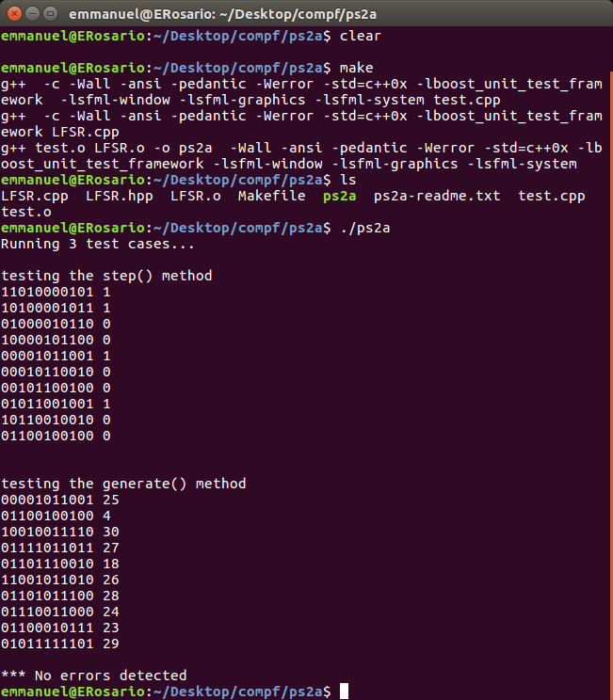

Makefile:

- CC = g++

- CFLAGS = -Wall -ansi -pedantic -Werror -std=c++0x -lboost_unit_test_framework

- OFLAGS = -c -Wall -ansi -pedantic -Werror -std=c++0x -lboost_unit_test_framework

- LFLAGS = -lsfml-window -lsfml-graphics -lsfml-system

- all: ps2a

- ps2a: test.o LFSR.o
- $(CC) test.o LFSR.o -o ps2a $(CFLAGS) $(LFLAGS)

- test.o: test.cpp
- $(CC) $(OFLAGS) $(LFLAGS) test.cpp

- LFSR.o: LFSR.cpp LFSR.hpp
- $(CC) $(OFLAGS) LFSR.cpp

- clean:
- rm *.o ps2a *.cpp~ *~

test.cpp

- include <iostream>
- #include <string>
- #include "LFSR.hpp"
- #define BOOST_TEST_DYN_LINK
- #define BOOST_TEST_MODULE Main
- #include <boost/test/unit_test.hpp>

- BOOST_AUTO_TEST_CASE(simulateonestep)
- {
- std::cout<<"\ntesting the step() method"<<std::endl;
- LFSR lfsr("01101000010", 8);
- for (int i = 0; i < 10; i++)
- {
- int r = lfsr.step();
- std::cout<<lfsr<< " "<< r<< std::endl;
- }
- std::cout<<"\n"<<std::endl;
- }

- BOOST_AUTO_TEST_CASE(simulategenerate)
- {
- std::cout<<"testing the generate() method"<<std::endl;
- LFSR lfsr("01101000010", 8);
- for (int i = 0; i < 10; i++)
- {
- int r = lfsr.generate(5);
- std::cout<<lfsr<< " "<< r<< std::endl;
- }

- }
- BOOST_AUTO_TEST_CASE(fiveBitsTapAtTwo) {

- LFSR l("00111", 2);
- BOOST_REQUIRE(l.step() == 1);
- BOOST_REQUIRE(l.step() == 1);
- BOOST_REQUIRE(l.step() == 0);
- BOOST_REQUIRE(l.step() == 0);
- BOOST_REQUIRE(l.step() == 0);
- BOOST_REQUIRE(l.step() == 1);
- BOOST_REQUIRE(l.step() == 1);
- BOOST_REQUIRE(l.step() == 0);

- LFSR l2("00111", 2);
- BOOST_REQUIRE(l2.generate(8) == 198);
- }

LFSR.hpp

- /*
- * LFSR.hpp
- *
- * Created on: Sun Mar 2 09:27:35 2014
- * Author: Fred Martin, fredm@cs.uml.edu
- * ed: Y. Rykalova fall 2016
- */

- #include <iostream>
- #include <string>

- class LFSR {

- public:
- LFSR(std::string seed, int tap);
- //~LFSR();
- int step();
- int generate(int k);

- friend std::ostream& operator<< (std::ostream &out, LFSR &lfsr);

- private:
- std::string _seed;
- int _tap;
- };

LFSR.cpp

- #include <iostream>
- #include <cmath>
- #include "LFSR.hpp"
- using namespace std;

- // constructor to create LFSR with the given initial seed and tap
- //which accepts a C++ String of 1 and 0 characters
- LFSR::LFSR(std::string seed, int t)
- {
- _seed = seed;
- _tap = t;

- }

- //int step() function of zero args which returns an int that will be a zero or a one
- //instead of implementing the toString method
- int LFSR::step()
- {

- std::string _bit;
- int seed_s = _seed.size();
- int bit_front = _seed[0];
- int tap_ = _seed[seed_s-_tap-1];
- int bit = bit_front ^ tap_;
- _bit = std::to_string(bit);
- _seed.erase(0,1);
- // std::cout<<"erase"<<_seed<<std::endl;
- _seed += _bit;
- // std::cout<<"add "<<_seed<<std::endl;
- return bit;

- }

- //call step() function and returns k-bit integer
- int LFSR::generate(int k)
- {
- int s = 0;

- for(int i= k;i>0; i--)
- {
- if(step() == 1)
- s += pow(2,i-1);
- }
- return s;

- }

- std::ostream& operator<<(std::ostream& out, LFSR& lsfr)
- {
- out << lsfr._seed;
- return out;
- }

PS2b Encoding images with LFSR

Assignment Summary:
The assignment PS2a was to create encoding and decoding images with LFSR. In Part B, we finish the linear feedback shift register. We added the Transform method, this method takes a picture and an LFSR as arguments and returns a new picture that is the result of transforming the argument picture using the linear feedback shift register as follows: get pixel with x and y values, assign the get pixel() to color or component with a generated 8-bit integer. The main() method we set the window to draw two images one will be decrypted and the other one will be encrypted like the fallowing examples:
Data Structures/Algorithms:
This assignment uses the same algorithms as the PS2a. however, when encrypting the image I used the colors.

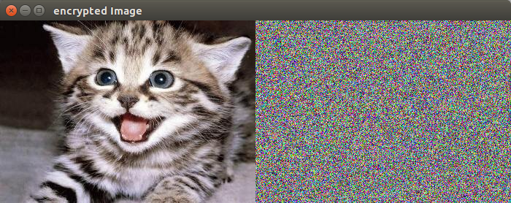

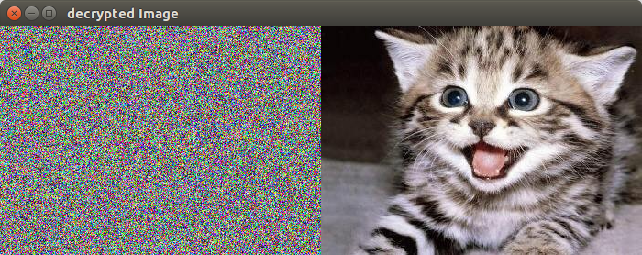

Makefile:

- CC = g++

- CFLAGS = -Wall -ansi -pedantic -Werror -std=c++0x -lboost_unit_test_framework

- OFLAGS = -c -Wall -ansi -pedantic -Werror -std=c++0x -lboost_unit_test_framework

- LFLAGS = -lsfml-window -lsfml-graphics -lsfml-system

- all: ps2b

- ps2b: PhotoMagic.o LFSR.o
- $(CC) PhotoMagic.o LFSR.o -o PhotoMagic $(CFLAGS) $(LFLAGS)

- PhotoMagic.o: PhotoMagic.cpp
- $(CC) $(OFLAGS) $(LFLAGS) PhotoMagic.cpp

- LFSR.o: LFSR.cpp LFSR.hpp
- $(CC) $(OFLAGS) LFSR.cpp

- clean:
- rm *.o PhotoMagic *.cpp~ *~

PhotoMagic.cpp:

- #include <SFML/System.hpp>
- #include <SFML/Window.hpp>
- #include <SFML/Graphics.hpp>
- #include <iostream>
- #include "LFSR.hpp"

- sf::Image transform(sf::Image picture, LFSR lfsr) {
- sf::Vector2u size = picture.getSize();
- sf::Color p;
- //x value
- for (unsigned x = 0; x < size.x; x++)
- {
- //y value
- for (unsigned y = 0; y < size.y; y++)
- {
- //get get pixel with x and y values
- //assing the get pixel() to p
- p = picture.getPixel(x, y);

- //color or component with a generated 8-bit integer
- p.r = p.r ^ lfsr.generate(8);
- p.g = p.g ^ lfsr.generate(8);
- p.b = p.b ^ lfsr.generate(8);

- //set x, y, and p to setpixel
- picture.setPixel(x, y, p);
- }
- }
- return picture;
- }

- int main(int argc, char *argv[]) {

- //loading the image
- sf::Image image;
- if (!image.loadFromFile("cat.jpg"))
- return -1;
- sf::Image imageOut;
- if (!imageOut.loadFromFile("cat.jpg"))
- return -1;
- LFSR lfsr("01101000010100010000", 16);
- imageOut = transform(imageOut, lfsr);
- sf::Vector2u size = image.getSize();
- sf::RenderWindow window(sf::VideoMode(size.x * 2, size.y), "Image");

- //first window with the decrypted image
- sf::Texture texture;
- texture.loadFromImage(image);
- sf::Sprite sprite;
- sprite.setTexture(texture);
- //sprite.setPosition(size.x, 0);

- //second window with the encrypted image
- sf::Texture textureOut;
- textureOut.loadFromImage(imageOut);
- sf::Sprite spriteOut;
- spriteOut.setTexture(textureOut);
- spriteOut.setPosition(size.x, 0);

- //windows event
- while (window.isOpen()) {
- sf::Event event;
- while (window.pollEvent(event)) {
- if (event.type == sf::Event::Closed)
- window.close();
- }
- window.clear();
- window.draw(sprite);
- window.draw(spriteOut);
- window.display();
- }
- if (!imageout.saveToFile("cat-out.bmp"))
- return -1;
- return 0;
- }

LFSR.hpp:

- /*
- * LFSR.hpp
- *
- * Created on: Sun Mar 2 09:27:35 2014
- * Author: Fred Martin, fredm@cs.uml.edu
- * ed: Y. Rykalova fall 2016
- */

- #include <iostream>
- #include <string>

- class LFSR {

- public:
- LFSR(std::string seed, int tap);
- //~LFSR();
- int step();
- int generate(int k);

- friend std::ostream& operator<< (std::ostream &out, LFSR &lfsr);

- private:
- std::string _seed;
- int _tap;
- };

LFSR.cpp

- #include <iostream>
- #include <cmath>
- #include "LFSR.hpp"
- using namespace std;

- // constructor to create LFSR with the given initial seed and tap
- //which accepts a C++ String of 1 and 0 characters
- LFSR::LFSR(std::string seed, int t)
- {
- _seed = seed;
- _tap = t;

- }

- //int step() function of zero args which returns an int that will be a zero or a one
- //instead of implementing the toString method
- int LFSR::step()
- {

- int seed_s = _seed.size();
- int bit_front = _seed[0];
- int tap_ = _seed[seed_s-_tap-1];
- int bit = bit_front ^ tap_;
- std::string _bit;
- _bit = std::to_string(bit);
- _seed.erase(0,1);
- // std::cout<<"erase"<<_seed<<std::endl;
- _seed += _bit;
- // std::cout<<"add "<<_seed<<std::endl;
- return bit;

- }

- //call step() function and returns k-bit integer
- int LFSR::generate(int k)
- {
- int s = 0;

- for(int i= k;i>0; i--)
- {
- if(step() == 1)
- s += pow(2,i-1);
- }
- return s;

- }

- std::ostream& operator<<(std::ostream& out, LFSR& lsfr)
- {
- out << lsfr._seed;
- return out;
- }

PS3a N-Body Simulation: Design a program that loads and displays a static universe
Summary:
This assignment was divided in two parts a and b. Part A, we will create a program that loads and displays a static universe. This is one of my favorite assignment because we had to make a static universe using the SFML graphics. Also, this program reads the universe from a text file “planets.txt”
Data Structures/Algorithms:
This program uses data structures like an array, to store all the planets information about the universe that are on the file.

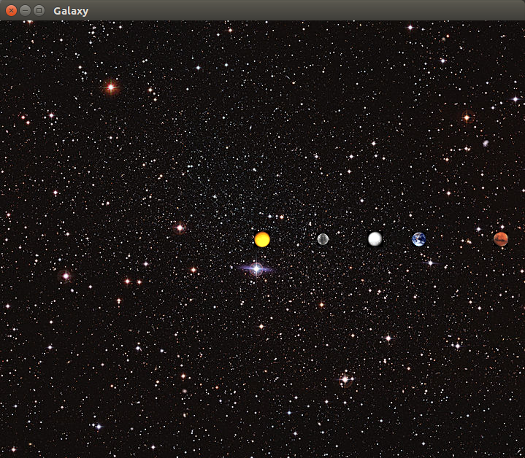
planets.txt:
5
2.50e+11
1.4960e+11 0.0000e+00 0.0000e+00 2.9800e+04 5.9740e+24 earth.gif
2.2790e+11 0.0000e+00 0.0000e+00 2.4100e+04 6.4190e+23 mars.gif
5.7900e+10 0.0000e+00 0.0000e+00 4.7900e+04 3.3020e+23 mercury.gif
0.0000e+00 0.0000e+00 0.0000e+00 0.0000e+00 1.9890e+30 sun.gif
1.0820e+11 0.0000e+00 0.0000e+00 3.5000e+04 4.8690e+24 venus.gif
[!] Your program should not read this line, as all 5 planets were already listed
and there is no further information to be specified. So you can put comments here.
This file contains the inner 4 planets of our solar system, and the sun.

Makefile:
- CC = g++
- OFLAGS = -c -Wall -ansi -pedantic -Werror -std=c++0x -lboost_unit_test_framework
- CFLAGS = -Wall -ansi -pedantic -Werror -std=c++0x -lboost_unit_test_framework
- LFLAGS = -lsfml-window -lsfml-graphics -lsfml-system

- all:NBody

- NBody: nbody.o main.o
- $(CC) nbody.o main.o $(CFLAGS) $(LFLAGS) -o NBody

- main.o: main.cpp
- $(CC) $(OFLAGS) $(LFLAGS) main.cpp

- nbody.o: nbody.cpp nbody.hpp
- $(CC) $(OFLAGS) nbody.cpp

- clean:
- rm *.o *~ NBody

main.cpp:

- #include <SFML/Graphics.hpp>
- #include <SFML/Window.hpp>
- #include <iostream>
- #include <vector>
- #include <string>
- #include "nbody.hpp"

- int main(int argc, char *argv[])
- {
- Planet **Planets = new Planet*[4];
- int num_planets= 0;
- int num1 = 0;
- double x_y = 0;
- double num2 = 0;

- //reading from the file planets.txt
- std::cin >> num1 >> num2;
- num_planets = num1;
- //get the scale
- x_y = num2;

- for (int i = 0; i<num_planets; i++) {
- Planets[i]= new Planet(0.0,0.0,0.0,0.0,0.0,"o");
- std::cin >> *Planets[i];
- }

- sf::Image background;
- //loading the backgroud
- if (!background.loadFromFile("galaxy.jpg"))
- return -1;
- //set the windows size with the background image
- sf::Vector2u size = background.getSize();
- sf::RenderWindow window(sf::VideoMode(size.x, size.y), "Solar System");
- sf::Texture texture;
- texture.loadFromImage(background);
- sf::Sprite sprite;
- sprite.setTexture(texture);

- //window set up
- while (window.isOpen()) {
- sf::Event event;
- while (window.pollEvent(event)) {
- if (event.type == sf::Event::Closed)
- window.close();
- }

- window.clear();
- window.draw(sprite);

- //drawing the planets
- for (int i=0; i<num_planets; i++) {
- (*Planets[i]).updatePosition(x_y, size.x/2, size.y/2);
- window.draw(*Planets[i]);
- }
- window.display();

- }
- return 0;

- }

nbody.hpp:
- #ifndef N_BODY_HPP_
- #define N_BODY_HPP_

- #include <SFML/Graphics.hpp>
- #include <SFML/Window.hpp>
- #include <iostream>

- class Planet : public sf::Drawable
- {

- private:
- double X;
- double Y;
- double X_Speed;
- double Y_Speed;
- double Mass;
- std::string Image;
- sf::Texture texture;
- sf::Image Planet_Image;
- sf::Sprite sprite;
- public:
- Planet(double x_pos, double y_pos, double x_vel, double y_vel,double mass, std::string image);
- //set position
- void setPosition(double x_pos, double y_pos);
- //set mass
- void setMass(double mass);
- //get x
- double get_x() const;
- //get y
- double get_y() const;
- //get mass
- double getMass();
- virtual void draw(sf::RenderTarget& target, sf::RenderStates states) const;
- void updatePosition(double scale,int window_x, int window_y);
- friend std::istream& operator>> (std::istream& in, Planet& planet);

- };

- #endif

nbody.cpp:
- #include <iostream>
- #include <SFML/System.hpp>
- #include <SFML/Window.hpp>
- #include <SFML/Graphics.hpp>
- #include "nbody.hpp"

- Planet::Planet(double x,double y,double xSpeed, double ySpeed,double mass, std::string image) {

- }
- void Planet:: draw(sf::RenderTarget& target, sf::RenderStates
- states)
- const {
- target.draw(sprite,states);

- }

- void Planet:: setPosition(double x, double y) {
- X = x;
- Y = y;
- }

- void Planet:: setMass(double mass) {
- Mass = mass;
- }
- double Planet:: get_x() const {
- return X;
- }

- double Planet:: get_y() const {
- return Y;
- }

- double Planet::getMass() {
- return Mass;
- }

- std::istream& operator>> (std::istream& in, Planet& planet) {
- in >> planet.X
- >> planet.Y
- >> planet.X_Speed
- >> planet.Y_Speed
- >> planet.Mass
- >> planet.Image;
- planet.Planet_Image.loadFromFile(planet.Image);
- planet.texture.loadFromImage(planet.Planet_Image);
- planet.sprite.setTexture(planet.texture);

- return in;
- }

- void Planet:: updatePosition(double scale,int window_x, int window_y) {

- sf::Vector2u size = Planet_Image.getSize();
- int X_Position = window_x-size.x/2+X/scale*window_x;
- int Y_Position = window_y-size.y/2+Y/scale*window_y;

- sprite.setPosition(X_Position,Y_Position);
- }

PS3b N-Body Simulation: Using Newton's laws of physics, animate the universe
Assignment Summary:
This assignment was divided in two parts a and b. Part B, we are adding physics simulation and animation to the program created in Part A. Also, we add it audio, and using all the equations from the Princeton’s web and reads all the values from planets.txt file.
Data Structures/Algorithms:
This program uses same data structures as part a and adding the animation.
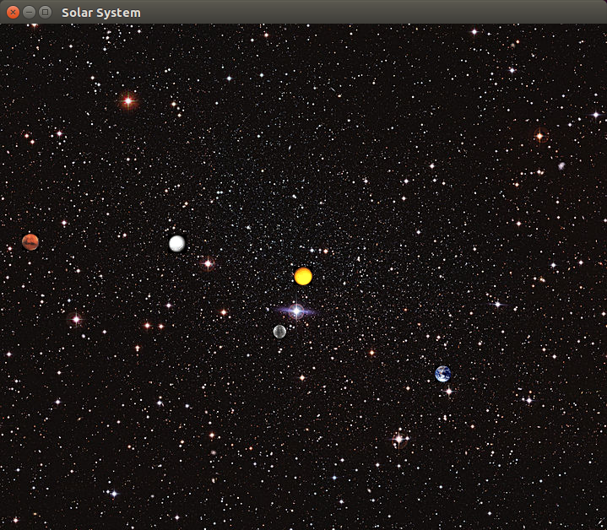

planets.txt:
5
2.50e+11
1.4960e+11 0.0000e+00 0.0000e+00 2.9800e+04 5.9740e+24 earth.gif
2.2790e+11 0.0000e+00 0.0000e+00 2.4100e+04 6.4190e+23 mars.gif
5.7900e+10 0.0000e+00 0.0000e+00 4.7900e+04 3.3020e+23 mercury.gif
0.0000e+00 0.0000e+00 0.0000e+00 0.0000e+00 1.9890e+30 sun.gif
1.0820e+11 0.0000e+00 0.0000e+00 3.5000e+04 4.8690e+24 venus.gif
[!] Your program should not read this line, as all 5 planets were already listed
and there is no further information to be specified. So you can put comments here.
This file contains the inner 4 planets of our solar system, and the sun.

Makefile:
- CC = g++
- OFLAGS = -c -Wall -ansi -pedantic -Werror -std=c++0x -lboost_unit_test_framework
- CFLAGS = -Wall -ansi -pedantic -Werror -std=c++0x -lboost_unit_test_framework
- LFLAGS = -lsfml-window -lsfml-graphics -lsfml-audio -lsfml-system

- all:NBody

- NBody: nbody.o main.o
- $(CC) nbody.o main.o $(CFLAGS) $(LFLAGS) -o NBody

- main.o: main.cpp
- $(CC) $(OFLAGS) $(LFLAGS) main.cpp

- nbody.o: nbody.cpp nbody.hpp
- $(CC) $(OFLAGS) nbody.cpp

- clean:
- rm *.o *~ NBody

main.cpp
- #include <SFML/Graphics.hpp>
- #include <SFML/Window.hpp>
- #include <SFML/Audio.hpp>
- #include <iostream>
- #include <vector>
- #include <ctime>
- #include <string>
- #include "nbody.hpp"

- int main(int argc, char *argv[])
- {
- Planet **Planets = new Planet*[4];
- int num_planets= 0;
- int num1 = 0;
- double x_y = 0;
- double num2 = 0;

- //time
- double time=10000;

- // Declare a new music
- sf::Music music;
- sf::Texture texture;
- sf::Sprite sprite;
- sf::Image background;

- //reading from the file planets.txt
- std::cin >> num1 >> num2;
- num_planets = num1;
- //get the scale
- x_y = num2;

- for (int i = 0; i<num_planets; i++) {
- Planets[i]= new Planet(0.0,0.0,0.0,0.0,0.0,"o");
- std::cin >> *Planets[i];
- (*Planets[i]).setnum_planets(num_planets);
- }
- //windows set up, planets' images and background
- //loading the backgroud
- if (!background.loadFromFile("galaxy.jpg"))
- return -1;
- //set the windows size with the background image
- sf::Vector2u size = background.getSize();
- sf::RenderWindow window(sf::VideoMode(size.x, size.y), "Solar System");

- texture.loadFromImage(background);
- sprite.setTexture(texture);

- //music set up
- if (!music.openFromFile("2001.ogg"))
- {
- std::cout<<"can't find 2001.ogg"<< std::endl;
- return -1;
- }

- music.setPosition(0, 1, 10); // change its 3D position
- music.setPitch(2); // increase the pitch
- music.setVolume(80); // reduce the volume
- music.setLoop(true); // make it loop
- music.play(); // play

- //window set up
- while (window.isOpen()) {
- sf::Event event;
- while (window.pollEvent(event)) {
- if (event.type == sf::Event::Closed)
- window.close();
- }

- window.setFramerateLimit(100); // Limit to 100 frames per second

- window.clear();
- window.draw(sprite);

- //planets animation
- (*Planets[0]).step(time,Planets,0);

- //drawing the planets
- for (int i=0; i<num_planets; i++)
- {
- (*Planets[i]).updatePosition(x_y, size.x/2, size.y/2);
- window.draw(*Planets[i]);
- }

- window.display();

- }
- return 0;

- }

nbody.hpp:
- #ifndef N_BODY_HPP_
- #define N_BODY_HPP_

- #include <SFML/Graphics.hpp>
- #include <SFML/Window.hpp>
- #include <iostream>

- class Planet : public sf::Drawable
- {

- private:
- double X;
- double Y;
- double X_Speed;
- double Y_Speed;
- double Mass;
- double num_planets;
- std::string Image;
- sf::Texture texture;
- sf::Image Planet_Image;
- sf::Sprite sprite;
- public:
- Planet(double x_pos, double y_pos, double x_vel, double y_vel,double mass, std::string image);
- //set position
- void setPosition(double x_pos, double y_pos);
- //set mass
- void setMass(double mass);
- //set the number of planets
- void setnum_planets(int num);
- //get x
- double get_x() const;
- //get y
- double get_y() const;
- //get mass
- double getMass();
- //get numbers of planets
- int getnum_planets();
- virtual void draw(sf::RenderTarget& target, sf::RenderStates states) const;
- void updatePosition(double scale,int window_x, int window_y);
- friend std::istream& operator>> (std::istream& in, Planet& planet);
- void step(double time,Planet **Planets,int planet);
- };

- #endif

nbody.cpp:
- #include <iostream>
- #include <SFML/System.hpp>
- #include <SFML/Window.hpp>
- #include <SFML/Graphics.hpp>
- #include "nbody.hpp"

- Planet::Planet(double x,double y,double xSpeed, double ySpeed,double mass, std::string image) {

- }
- void Planet:: draw(sf::RenderTarget& target, sf::RenderStates
- states)
- const {
- target.draw(sprite,states);

- }

- void Planet:: setPosition(double x, double y) {
- X = x;
- Y = y;
- }

- void Planet:: setMass(double mass) {
- Mass = mass;
- }
- double Planet:: get_x() const {
- return X;
- }

- double Planet:: get_y() const {
- return Y;
- }

- double Planet::getMass() {
- return Mass;
- }

- void Planet::setnum_planets(int num)
- {
- num_planets = num;
- }

- int Planet::getnum_planets()
- {
- return num_planets;
- }
- std::istream& operator>> (std::istream& in, Planet& planet) {
- in >> planet.X
- >> planet.Y
- >> planet.X_Speed
- >> planet.Y_Speed
- >> planet.Mass
- >> planet.Image;
- planet.Planet_Image.loadFromFile(planet.Image);
- planet.texture.loadFromImage(planet.Planet_Image);
- planet.sprite.setTexture(planet.texture);

- return in;
- }

- void Planet:: updatePosition(double scale,int window_x, int window_y) {

- sf::Vector2u size = Planet_Image.getSize();
- int X_Position = window_x-size.x/2+X/scale*window_x;
- int Y_Position = window_y-size.y/2+Y/scale*window_y;

- sprite.setPosition(X_Position,Y_Position);
- }

- //step method
- void Planet:: step(double time,Planet **Planets,int planet)
- {
- //the gravitational constant G (6.67 × 10-11 N m2 / kg2)
- double r;
- double F;
- double FX;
- double FY;

- for (int i=0;i<getnum_planets();i++)
- {
- if (planet!=i)
- {

- /*all the following equations were given by princeton
- http://www.cs.princeton.edu/courses/archive/fall13/cos126/assignments/nbody.html*/

- //find the pairwise force
- r = sqrt(pow(X-(*Planets[i]).X,2)+pow(Y-(*Planets[i]).Y,2));
- F = (6.67e-11)*(*Planets[i]).Mass*Mass/pow(r,2);

- //find the net force
- FX = F*(X-(*Planets[i]).X)/r;
- FY = F*(Y-(*Planets[i]).Y)/r;

- //find the acceleration
- X_Speed = X_Speed+time*FX/Mass;
- Y_Speed = Y_Speed+time*FY/Mass;

- }

- }

- if (planet<getnum_planets()-1)

- (*Planets[planet+1]).step(time, Planets, planet+1);
- X -=(time*X_Speed);
- Y -=(time*Y_Speed);

- }

PS4 Edit Distance
Summary
This assignment was to write a program to compute the optimal sequence alignment of two DNA strings. This assignment measures the similarity of two genetic sequences by their edit distance. This program come a penalty rule; if matching two of the same characters costs a penalty of 0, matching different characters costs a penalty of 1, and matching a character with a gap costs a penalty of 2. I was not a big fan of this program I had a hard time understanding it, of the two times I went to see the TA this semester this one was one than.

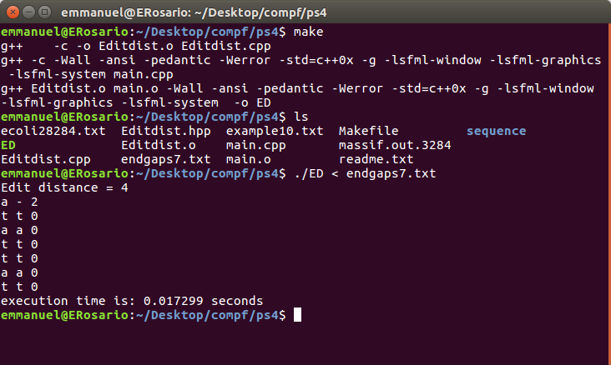
endgaps7.txt:
atattat
tattata

Makefile:
- CC = g++
- OFLAGS = -c -Wall -ansi -pedantic -Werror -std=c++0x -g
- CFLAGS = -Wall -ansi -pedantic -Werror -std=c++0x -g
- LFLAGS = -lsfml-window -lsfml-graphics -lsfml-system

- all: ED

- ED: Editdist.o main.o
- $(CC) Editdist.o main.o $(CFLAGS) $(LFLAGS) -o ED

- main.o: main.cpp
- $(CC) $(OFLAGS) $(LFLAGS) main.cpp

- ED.o: Editdist.cpp Editdist.hpp
- $(CC) $(OFLAGS) Editdist.cpp
- clean:
- rm -f *.o *~ ED main

main.cpp:
- #include <SFML/System.hpp>
- #include <string>
- #include <iostream>
- #include "Editdist.hpp"

- int main(int argc, char *argv[]) {

- sf::Clock clock;
- sf::Time time;

- std::string string1;
- std::string string2;

- int edit_distance;

- std::cin >> string1 >> string2;
- ED edit_dist (string1, string2);
- edit_distance = edit_dist.OptDistance();

- std::cout << "Edit distance" << " = " << edit_distance << std::endl;
- std::string result = edit_dist.Alignment();
- int size = result.size();
- for (int i = 0; i < size; i += 3) {
- std::cout << result[i] << " " << result[i + 1] << " "
- << result[i + 2]<< std::endl;
- }
- time = clock.getElapsedTime();
- std::cout << "execution time is: " << time.asSeconds() << " seconds \n";

- return 0;
- }

Editdist.hpp:
- #ifndef ED_HPP_
- #define ED_HPP_

- #include <SFML/Graphics.hpp>
- #include <SFML/Window.hpp>
- #include <string>

- class ED {
- private:
- std::string string_1;
- std::string string_2;
- // length of both string_1 and string_2
- int string1_size;
- int string2_size;
- int **distance;

- public:
- ED(std::string s1, std::string s2);
- int penalty(char a, char b);
- int min(int a, int b, int c);
- int OptDistance();
- std::string Alignment();
- };

- #endif

Editdist.cpp:
- #include <iostream>
- #include <string>
- #include <algorithm>
- #include "Editdist.hpp"
- using namespace std;

- ED::ED(std::string s1, std::string s2) {

- string_1 = s1;
- string_2 = s2;

- distance = new int*[string_1.size()+1 ];
- for (int i = 0; i <= string_1.size(); i++)
- distance[i]= new int[string_2.size()+1];

- //after adding this lines of code
- //the edit distance is working
- for (int i = 0; i <= string_1.size(); i++)
- distance[i][string_2.size()] = ((string_1.size() - i) * 2);
- for (int j = 0; j <= string_2.size(); j++)
- distance[string_1.size()][j] = ((string_2.size() - j) * 2);

- }

- int ED:: penalty(char x, char y) {
- if (x == y)
- return 0;
- else
- return 1;
- }

- int ED::min(int a, int b, int c) {
- /* if (a < b && a < c)
- return a;
- if (b < c)
- return b;
- return c;
- //*/
- return std::min(std::min(a, b),c);
- }

- int ED::OptDistance() {
- for (int x = string_2.size()-1; x >= 0; x--) {
- for (int y = string_1.size()-1; y >= 0; y--) {
- if (!(penalty(string_1[y], string_2[x]))) {
- distance[y][x] = distance[y+1][x+1];
- } else {
- distance[y][x] = min(distance[y][x+1]+2,
- distance[y+1][x]+2, distance[y+1][x+1]+1);
- // distance[y][x] = min(distance[y][x+1] + (penalty(string_1[x], string_2[y])), distance[x+1][y]+2, distance[x][y+1]+2);
- }
- }

- }
- return distance[0][0];
- }

- std::string ED::Alignment() {
- std::string Align;
- int x = 0;
- int y = 0;
- ///*
- int i = 0;
- if(string_1.size() < string_2.size())
- i=string_2.size();
- else
- i=string_1.size();
- // */
- while (x<string_1.size() && y<string_2.size()) {
- //while(x<i&&y<i){
- if (!(penalty(string_1[x], string_2[y]))) {
- Align = Align + string_1[x] + string_2[y] + "0";
- x++;
- y++;
- } else if (distance[x][y] == (distance[x+2][y])) {
- Align = Align + string_1[x] + "-" + "2";
- x++;
- } else if (distance[x][y] == (distance[x][y+2])) {
- Align = Align + "-" + string_2[y]+ "2";
- y++;
- } else {
- Align = Align + string_1[x] + string_2[y] + "1";
- x++;
- y++;
- }
- }

- return Align;

- }

PS5a Ring Buffer with cpplint, testing, and exceptions
Summary:
This assignment like many we had this semester was dived into two parts. In Part A, we implement the ring buffer that will hold the guitar string position data, and write test functions and exception handling. We were give the implementation and what each of the functions are do. For this assignment was the first time we had to use cpplint. Also, were given a test file as well.
Data Structures/Algorithms:
This program uses queue for data structures and the algorithms was straight forward. Also, The vector was of type 16-bit integer which represented the guitar string position data.

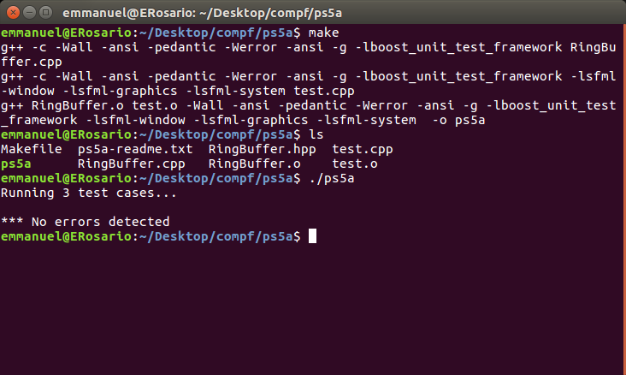
Makefile:
- CC = g++
- OFLAGS = -c -Wall -ansi -pedantic -Werror -ansi -g -lboost_unit_test_framework
- CFLAGS = -Wall -ansi -pedantic -Werror -ansi -g -lboost_unit_test_framework
- LFLAGS = -lsfml-window -lsfml-graphics -lsfml-system

- all:RingBuffer

- RingBuffer: RingBuffer.o test.o
- $(CC) RingBuffer.o test.o $(CFLAGS) $(LFLAGS) -o ps5a

- test.o: test.cpp
- $(CC) $(OFLAGS) $(LFLAGS) test.cpp

- RingBuffer.o: RingBuffer.cpp RingBuffer.hpp
- $(CC) $(OFLAGS) RingBuffer.cpp

- clean:
- rm -f *.o *~ RingBuffer test ps5a

test..cpp:
- #define BOOST_TEST_DYN_LINK
- #define BOOST_TEST_MODULE Main
- #include <boost/test/unit_test.hpp>

- #include <stdint.h>
- #include <iostream>
- #include <string>
- #include <exception>
- #include <stdexcept>
- #include "RingBuffer.hpp"

- BOOST_AUTO_TEST_CASE(RBcontructor) {
- // normal constructor
- BOOST_REQUIRE_NO_THROW(RingBuffer(100));

- // this should fail
- BOOST_REQUIRE_THROW(RingBuffer(0), std::exception);
- BOOST_REQUIRE_THROW(RingBuffer(0), std::invalid_argument);
- }

- BOOST_AUTO_TEST_CASE(RBenque_dequeue) {
- RingBuffer rb(100);

- rb.enqueue(2);
- rb.enqueue(1);
- rb.enqueue(0);

- BOOST_REQUIRE(rb.dequeue() == 2);
- BOOST_REQUIRE(rb.dequeue() == 1);
- BOOST_REQUIRE(rb.dequeue() == 0);

- BOOST_REQUIRE_THROW(rb.dequeue(), std::runtime_error);
- }

- //checks for isEmpty(),peek() and isfull
- BOOST_AUTO_TEST_CASE(sample) {
- RingBuffer rb(3);

- BOOST_REQUIRE(rb.isEmpty() == 1);
- rb.enqueue(2);
- rb.enqueue(1);
- rb.enqueue(0);

- BOOST_REQUIRE(rb.isEmpty() == 0);
- BOOST_REQUIRE(rb.peek() == 2);
- BOOST_REQUIRE(rb.Size() == 3);
- BOOST_REQUIRE(rb.isFull() == 1);
- }

RingBuffer,hpp:
- #ifndef RingBuffer_HPP
- #define RingBuffer_HPP
- #include <stdint.h>
- #include <vector>

- class RingBuffer {
- public:
- explicit RingBuffer(int Capacity);
- int Size();
- bool isEmpty();
- bool isFull();
- void enqueue(int16_t x);
- int16_t dequeue();
- int16_t peek();

- private:
- std::vector<int16_t> ringBuffer;
- int capacity;
- int size;
- int head;
- int tail;
- };

- #endif

RingBuffer,cpp:
- #include <stdint.h>
- #include <vector>
- #include <iostream>
- #include <stdexcept>
- #include "RingBuffer.hpp"

- RingBuffer::RingBuffer(int Capacity) : capacity(Capacity) {
- if (capacity <= 0) {
- throw std::invalid_argument("capacity must be greater than zero.");
- }else{
- ringBuffer.reserve(capacity);
- head = capacity-1;
- tail = capacity-1;
- size = 0;
- }
- }

- int RingBuffer::Size() {
- return size;
- }

- bool RingBuffer::isEmpty() {
- if (Size() == 0)
- return true;
- else
- return false;
- }

- bool RingBuffer::isFull() {
- if (Size() == capacity)
- return true;
- else
- return false;
- }

- void RingBuffer::enqueue(int16_t x) {
- if (!isFull()){
- if(Size() == 0){
- ringBuffer[head]=x;
- size++;
- }else{
- if(tail == 0){
- tail = capacity-1;
- ringBuffer[tail]=x;
- size++;
- }else{
- ringBuffer[tail-1]=x;
- tail--;
- size++;
- }
- }
- }else
- throw std::runtime_error("can't enqueue to a full ring.");
- }

- int16_t RingBuffer::dequeue() {
- int16_t temp = ringBuffer[head];
- if (!isEmpty()){

- if(head-1 < 0 && Size()> 1){
- for(int16_t i =0; i< Size()-1; i++)
- {
- ringBuffer[head]=0;
- head = capacity-1;
- }
- }else{
- ringBuffer[head]=0;
- if(Size()>1)
- head--;
- }
- size--;
- return temp;
- } else
- throw std::runtime_error("can't dequeue a empty ring.");
- }

- int16_t RingBuffer::peek() {
- if (!isEmpty())
- return ringBuffer[head];
- else
- throw std::runtime_error("can't peek a empty ring.");
- }

PS5b GuitarHero
In Part B, we implement the Karplus-Strong guitar string simulation, and generate a stream of string samples for audio playback under keyboard control. We had to use the all the class from part A, and write a class named GuitarString that performs the Karplus-Strong string simulation described in the Princeton assignment. Addition, we had to write a GutarHero program that supports a total of 37 notes on the chromatic scale from 110Hz to 880Hz. Use the following 37 keys to represent the keyboard, from lowest note to highest note:
String keyboard = "q2we4r5ty7u8i9op-[=zxdcfvgbnjmk,.;/' ";
Data Structures/Algorithms:
We used the Karplus-Strong algorithm to simulate the plucking of the guitar string.

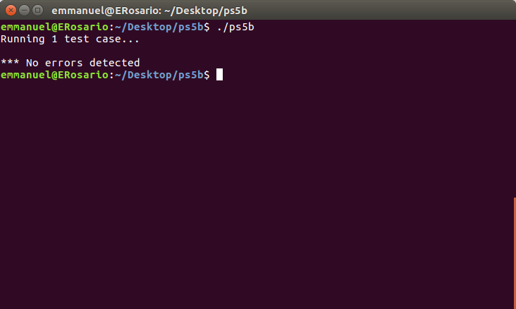

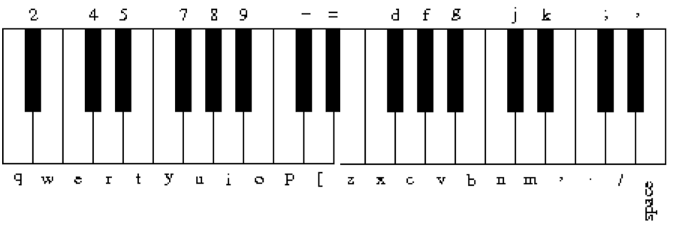
Makefile:
- CC = g++
- CFLAGS = -Wall -ansi -pedantic -Werror -std=c++0x -lboost_unit_test_framework
- LFLAGS = -lsfml-window -lsfml-graphics -lsfml-audio -lsfml-system

- all: GuitarHero gst

- GuitarHero: GuitarString.o GuitarHero.o RingBuffer.o
- $(CC) GuitarString.o GuitarHero.o RingBuffer.o $(CFLAGS) $(LFLAGS) -o GuitarHero

- gst: GuitarString.o GStest.o RingBuffer.o
- $(CC) GuitarString.o GStest.o RingBuffer.o $(CFLAGS) $(LFLAGS) -o gst

- GuitarHero.o: GuitarHero.cpp GuitarString.hpp RingBuffer.hpp
- $(CC) -c $(CFLAGS) $(LFLAGS) GuitarHero.cpp

- GStest.o: GStest.cpp GuitarString.hpp RingBuffer.hpp
- $(CC) -c $(CFLAGS) $(LFLAGS) GStest.cpp

- GuitarString.o: GuitarString.cpp GuitarString.hpp RingBuffer.hpp
- $(CC) -c $(CFLAGS) $(LFLAGS) GuitarString.cpp

- RingBuffer.o: RingBuffer.cpp RingBuffer.hpp
- $(CC) -c $(CFLAGS) $(LFLAGS) RingBuffer.cpp

- clean:
- rm *.o GuitarHero gst *.hpp~ *.cpp~

Gstest.cpp:
- /*
- Copyright 2015 Fred Martin, fredm@cs.uml.edu
- Wed Apr 1 09:43:12 2015
- test file for GuitarString class

- compile with
- g++ -c GStest.cpp -lboost_unit_test_framework
- g++ GStest.o GuitarString.o RingBuffer.o -o GStest -lboost_unit_test_framework
- */

- #define BOOST_TEST_DYN_LINK
- #define BOOST_TEST_MODULE Main
- #include <boost/test/unit_test.hpp>
- #include "GuitarString.hpp"

- BOOST_AUTO_TEST_CASE(GS) {
- std:: vector<sf::Int16> v;

- v.push_back(0);
- v.push_back(2000);
- v.push_back(4000);
- v.push_back(-10000);

- BOOST_REQUIRE_NO_THROW(GuitarString gs = GuitarString(v));

- GuitarString gs = GuitarString(v);

- // GS is 0 2000 4000 -10000
- BOOST_REQUIRE(gs.sample() == 0);

- gs.tic();
- // it's now 2000 4000 -10000 996
- BOOST_REQUIRE(gs.sample() == 2000);

- gs.tic();
- // it's now 4000 -10000 996 2988
- BOOST_REQUIRE(gs.sample() == 4000);

- gs.tic();
- // it's now -10000 996 2988 -2988
- BOOST_REQUIRE(gs.sample() == -10000);

- gs.tic();
- // it's now 996 2988 -2988 -4483
- BOOST_REQUIRE(gs.sample() == 996);

- gs.tic();
- // it's now 2988 -2988 -4483 1984
- BOOST_REQUIRE(gs.sample() == 2988);

- gs.tic();
- // it's now -2988 -4483 1984 0
- BOOST_REQUIRE(gs.sample() == -2988);

- // a few more times
- gs.tic();
- BOOST_REQUIRE(gs.sample() == -4483);
- gs.tic();
- BOOST_REQUIRE(gs.sample() == 1984);
- gs.tic();
- BOOST_REQUIRE(gs.sample() == 0);
- }

RingBuffer.hpp:
- // Copyright 2016 Emmanuel Rosario
- #ifndef _HOME_EMMANUEL_DESKTOP_PS5B_RINGBUFFER_HPP_
- #define _HOME_EMMANUEL_DESKTOP_PS5B_RINGBUFFER_HPP_
- #include <stdint.h>
- #include <vector>

- class RingBuffer {
- public:
- explicit RingBuffer(int Capacity);
- int Size();
- bool isEmpty();
- bool isFull();
- void enqueue(int16_t x);
- int16_t dequeue();
- int16_t peek();

- private:
- std::vector<int16_t> ringBuffer;
- int capacity;
- int size;
- int head;
- int tail;
- };

- #endif // _HOME_EMMANUEL_DESKTOP_PS5B_RINGBUFFER_HPP_

GutarString.hpp;
- // Copyright 2016 Emmanuel Rosario
- #ifndef _HOME_EMMANUEL_DESKTOP_PS5B_GUITARSTRING_HPP_
- #define _HOME_EMMANUEL_DESKTOP_PS5B_GUITARSTRING_HPP_
- #include <stdint.h>
- #include <SFML/Audio.hpp>
- #include <vector>
- #include "RingBuffer.hpp"

- class GuitarString {
- public:
- explicit GuitarString(double frequency);
- explicit GuitarString(std::vector<sf::Int16> init);
- void pluck();
- void tic();
- sf::Int16 sample();
- int time();
- private:
- int _time;
- RingBuffer* RB;
- };

- #endif // _HOME_EMMANUEL_DESKTOP_PS5B_GUITARSTRING_HPP_

GutarString.cpp;
- // Copyright 2016 Emmanuel Rosario
- #include <stdint.h>
- #include <math.h>
- #include <exception>
- #include <stdexcept>
- #include <vector>
- #include "GuitarString.hpp"
- #include "RingBuffer.hpp"

- GuitarString::GuitarString(double frequency) {
- if (frequency < 0) {
- throw std::invalid_argument("capacity must be greater than zero");
- } else {
- int capacity = 44100.0/frequency + .05;
- RB = new RingBuffer(capacity);
- for (int i = 0; i < capacity; i++) {
- (*RB).enqueue(0);
- }
- _time = 0;
- }
- }

- GuitarString::GuitarString(std::vector<sf::Int16> init) {
- if (init.size() <= 0) {
- throw std::invalid_argument("capacity must be greater than zero");
- } else {
- RB = new RingBuffer(init.size());
- for (unsigned i = 0; i < init.size() ; i++) {
- (*RB).enqueue(init.at(i));
- }
- _time = 0;
- }
- }

- void GuitarString::pluck() {
- while (!(*RB).isEmpty()) {
- (*RB).dequeue();
- }
- while (!(*RB).isFull()) {
- (*RB).enqueue((sf::Int16)(rand() & 0xffff));
- }
- }

- void GuitarString::tic() {
- int16_t temp = (((*RB).dequeue() + (*RB).peek())/2) * .996;
- (*RB).enqueue(temp);
- _time++;
- }

- sf::Int16 GuitarString::sample() {
- return (*RB).peek();
- }

- int GuitarString::time() {
- return _time;
- }

GuitarHero.cpp:
- // Copyright 2016 Emmanuel Rosario and an extension from Fred Martin
- #include <SFML/Graphics.hpp>
- #include <SFML/System.hpp>
- #include <SFML/Audio.hpp>
- #include <SFML/Window.hpp>
- #include "GuitarString.hpp"
- #define CONCERT_A 440.0
- #define SAMPLES_PER_SEC 44100

- std::vector<sf::Int16> makeSamplesFromString(GuitarString* gs) {
- std::vector<sf::Int16> samples;
- gs->pluck();
- int duration = 8; // seconds
- int i;
- for (i= 0; i < SAMPLES_PER_SEC * duration; i++) {
- gs->tic();
- samples.push_back(gs->sample());
- }
- return samples;
- }

- int main() {
- sf::Image image;
- std::vector<sf::Int16> samples;
- if (!image.loadFromFile("keyboard.png"))
- return -1;
- sf::Vector2u size = image.getSize();
- sf::RenderWindow window(sf::VideoMode(size.x, size.y), "Guitar Hero");

- sf::Texture texture;
- texture.loadFromImage(image);
- sf::Sprite sprite;
- sprite.setTexture(texture);
- std::vector<std::vector<sf::Int16> > Samples;

- std::vector<sf::SoundBuffer> SoundBuffers;
- std::vector<sf::Sound> Sounds;
- Samples.reserve(37);
- SoundBuffers.resize(37);
- Sounds.resize(37);

- for (double i = 0.0; i < 37; i++) {
- GuitarString gs(CONCERT_A * pow(2, (i-24)/12.0));
- Samples.push_back(makeSamplesFromString(&gs));
- if (!(SoundBuffers[i]).loadFromSamples(&Samples[i][0],
- Samples[i].size(), 2, SAMPLES_PER_SEC))
- throw std::runtime_error("sf::SoundBuffer: failed to load from samples.");
- Sounds[i].setBuffer(SoundBuffers[i]);
- }

- char keyboard[] = "q2we4r5ty7u8i9op-[=zxdcfvgbnjmk,.;/' ";

- while (window.isOpen()) {
- sf::Event event;
- while (window.pollEvent(event)) {
- if (event.type == sf::Event::Closed)
- window.close();
- for (int i = 0; i < 37; i++) {
- if (event.type == sf::Event::TextEntered) {
- if (event.text.unicode == (unsigned)keyboard[i]) {
- Sounds[i].play();
- }
- }
- }

- window.clear();
- window.draw(sprite);
- window.display();
- }
- }
- return 0;
- }

PS6 Markov Model
Summary:
In this assignment, we analyze an input text for transitions between k-grams a fixed number of characters and the following letter. We were given all the implementation to implement MrkovModel class. For this program we used the Markov model of natural langues. When I was writing this program was my first using map.

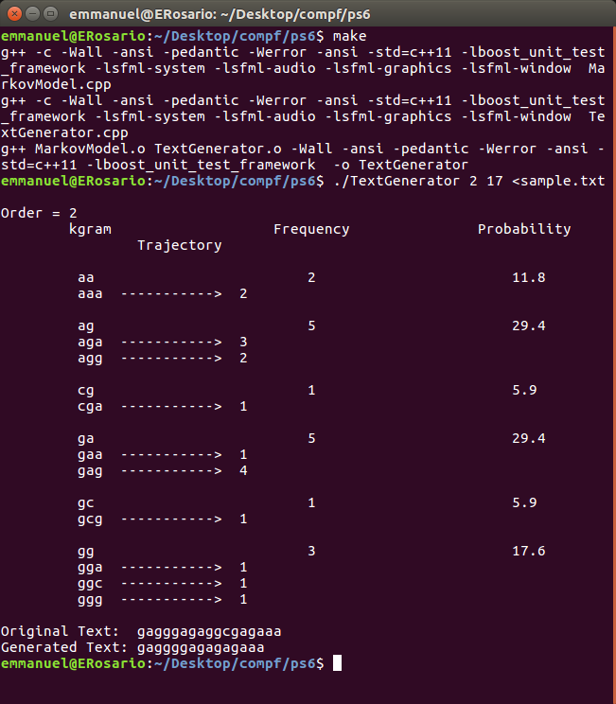

sample.txt:
gagggagaggcgagaaa

Makefile:

- CC = g++
- OFLAGS = -c -Wall -ansi -pedantic -Werror -ansi -std=c++11 -lboost_unit_test_framework
- CFLAGS = -Wall -ansi -pedantic -Werror -ansi -std=c++11 -lboost_unit_test_framework
- LFLAGS = -lsfml-system -lsfml-audio -lsfml-graphics -lsfml-window

- all: TextGenerator

- TextGenerator: MarkovModel.o TextGenerator.o
- $(CC) MarkovModel.o TextGenerator.o $(CFLAGS) -o TextGenerator

- MarkovModel.o: MarkovModel.cpp MarkovModel.hpp
- $(CC) $(OFLAGS) $(LFLAGS) MarkovModel.cpp

- TextGenerator.o: TextGenerator.cpp
- $(CC) $(OFLAGS) $(LFLAGS) TextGenerator.cpp

- clean:
- rm -f *.o *~ TextGenerator

TextGenerator.cpp:

// Copyright 2016 Emmanuel Rosario
#include <time.h>
#include <stdlib.h>
#include <exception>
#include <stdexcept>
#include <string>
#include <iostream>
#include "MarkovModel.hpp"

int main(int argc, char* argv[]) {
int order = atoi(argv[1]);
int t = atoi(argv[2]);
std::string input, kgram;
std::getline(std::cin, input);

MarkovModel mm(input, order);
std::cout << mm << std::endl;

kgram = input.substr(0, order);
std::string generated_text = mm.gen(kgram, t-order);

std::cout << "Original Text: " << input << std::endl;
std::cout << "Generated Text: " << generated_text << std::endl;

return 0;
}

MarkovModel.hpp:
- // Copyright 2016 Emmanuel Rosario

- #ifndef _HOME_EMMANUEL_DESKTOP_PS6_MARKOVMODEL_HPP_
- #define _HOME_EMMANUEL_DESKTOP_PS6_MARKOVMODEL_HPP_
- #include <map>
- #include <string>

- class MarkovModel {
- public:
- MarkovModel(std::string text, int k);
- ~MarkovModel();
- int order();
- int freq(std::string kgram);
- int freq(std::string kgram, char c);
- char randk(std::string kgram);
- std::string gen(std::string kgram, int T);

- friend std::ostream& operator <<(std::ostream& out, MarkovModel& mm);

- private:
- int _order;
- int _okgram;
- std::map <std::string, int> _kgrams;
- std::string _alphabet;
- };
- #endif // _HOME_EMMANUEL_DESKTOP_PS6_MARKOVMODEL_HPP_

MarkovModel.cpp:
- // Copyright 2016 Emmanuel Rosario
- #include <map>
- #include <vector>
- #include <exception>
- #include <stdexcept>
- #include <iostream>
- #include <string>
- #include <algorithm>
- #include "MarkovModel.hpp"

- MarkovModel::MarkovModel(std::string text, int k) {
- std::string kgram_str, _str, wrap;
- int temp, _kgram;
- _alphabet = text;
- _order = k;
- if ((unsigned) _order >= text.length())
- throw std::runtime_error("k value is to large");
- for (unsigned int i = 1; i < text.length()+1; i++) {
- _kgram = i+k-1;

- if ((unsigned) _kgram >= text.length()) {
- temp = _kgram - text.length() + 1;
- wrap = text.substr(0, temp);
- kgram_str = text.substr(i, text.length()-1) + wrap;
- _str = kgram_str + text.at(temp);
- } else {
- kgram_str = text.substr(i, k);
- if ((unsigned) _kgram+1 >= text.length()) {
- _str = kgram_str + text.at(i);
- } else {
- _str = text.substr(i, k+1);
- }
- }

- std::map<std::string, int>::iterator kg_ = _kgrams.find(kgram_str);
- if (kg_ != _kgrams.end()) {
- (*kg_).second += 1;
- } else {
- _kgrams[kgram_str] = 1;
- }

- std::map<std::string, int>::iterator kg = _kgrams.find(_str);
- if (kg != _kgrams.end()) {
- (*kg).second += 1;
- } else {
- _kgrams[_str] = 1;
- }
- }
- }

- MarkovModel::~MarkovModel() {
- }

- int MarkovModel::order() {
- return _order;
- }

- int MarkovModel::freq(std::string kgram) {
- if (kgram.length() != (unsigned)order()) {
- throw std::runtime_error("kgram does not match order size");
- }
- std::map<std::string, int>::iterator kg = _kgrams.find(kgram);
- if (kg != _kgrams.end()) {
- return (*kg).second;
- } else {
- return 0;
- }
- }

- int MarkovModel::freq(std::string kgram, char c) {
- unsigned int i, j = 0;
- if (kgram.length() != (unsigned) _order)
- throw std::runtime_error("kgram does not match order size");
- if (_order == 0) {
- for (i = 0; i < kgram.length(); i++) {
- if (kgram.at(i) == c)
- j++;
- }
- return j;
- }

- std::string str(1, c);
- std::string temp = kgram + str;
- std::map<std::string, int>::iterator _kg = _kgrams.find(temp);
- if (_kg != _kgrams.end()) {
- return (*_kg).second;
- } else {
- return 0;
- }
- }

- char MarkovModel::randk(std::string kgram) {
- std::vector<char> temp;
- int _rand;
- if (kgram.length() != (unsigned)_order) {
- throw std::runtime_error("kgram does not match order size"); }
- if (freq(kgram) == 0) {
- throw std::runtime_error("kgram is not found");
- }
- for (unsigned int i = 0; i < _alphabet.length(); i++) {
- char kplus_c = _alphabet.at(i);
- int kplus_f = freq(kgram, kplus_c);
- for (int j = 0; j < kplus_f; j++) {
- temp.push_back(kplus_c);
- }
- }

- _rand = rand() % temp.size(); // NOLINT
- return temp[_rand];
- }

- std::string MarkovModel::gen(std::string kgram, int T) {
- std::string _gen = kgram;
- _okgram = T;
- if (kgram.length() != (unsigned)order()) {
- throw std::runtime_error("kgram does not match order size");
- }
- while (_gen.length() < (unsigned) T) {
- std::string str(1, randk(kgram));
- _gen.append(str);
- if (_order > 0) {
- kgram = kgram.substr(1);
- }
- std::string temp = kgram + str;
- kgram = temp;
- }
- return _gen;
- }

- std::ostream& operator << (std::ostream& out, MarkovModel& mm) {
- std::cout << std::endl << "Order = " << mm._order << std::endl;
- std::map<std::string, int>::iterator _kg;
- std::cout << "\tkgram\t\t\tFrequency\t\tProbability " << std::endl;
- mm._okgram = mm._alphabet.size();
- std::cout << "\t\tTrajectory"<< std::endl;
- for (_kg = mm._kgrams.begin(); _kg != mm._kgrams.end(); ++_kg) {
- if ((*_kg).first.length() == (unsigned) mm._order) {
- std::cout << std::endl;
- std::cout << " \t "<< (*_kg).first <<" \t\t\t "<< (*_kg).second;
- double percentage = (static_cast<double>((*_kg).second)/ mm._okgram)*100;
- std::cout << " \t\t\t ";
- std::printf("%.1f", percentage);
- std::cout << std::endl;
- } else {
- std::cout << " \t ";
- std::cout <<(*_kg).first << " -----------> " <<(*_kg).second;
- std::cout << std::endl;
- }
- }

- return out;
- }

PS7a Kronos Intouch parsing part A
Summary:
This assignment like many we had this semester was dived into two parts. In Part A, in this assignment, we begin the analysis of the Kronos InTouch time clock log by using regular expressions to parse the file. There were no data structures or algorithms used for this assignment. It ones of the easies assignments were all years. However, I had to do some research on regex and how to use it because it my first times. This uses regex and if finds what I looking for it would had the output in a file. For example:

device1_intouch.log.rpt
=== Device boot ===
435369(device1_intouch.log): 2014-03-25 19:11:59 Boot Start
435759(device1_intouch.log): 2014-03-25 19:15:02 Boot Completed
Boot Time: 183000ms

=== Device boot ===
436500(device1_intouch.log): 2014-03-25 19:29:59 Boot Start
436859(device1_intouch.log): 2014-03-25 19:32:44 Boot Completed
Boot Time: 165000ms

=== Device boot ===
440719(device1_intouch.log): 2014-03-25 22:01:46 Boot Start
440791(device1_intouch.log): 2014-03-25 22:04:27 Boot Completed
Boot Time: 161000ms

=== Device boot ===
440866(device1_intouch.log): 2014-03-26 12:47:42 Boot Start
441216(device1_intouch.log): 2014-03-26 12:50:29 Boot Completed
Boot Time: 167000ms

=== Device boot ===
442094(device1_intouch.log): 2014-03-26 20:41:34 Boot Start
442432(device1_intouch.log): 2014-03-26 20:44:13 Boot Completed
Boot Time: 159000ms

=== Device boot ===
443073(device1_intouch.log): 2014-03-27 14:09:01 Boot Start
443411(device1_intouch.log): 2014-03-27 14:11:42 Boot Completed
Boot Time: 161000ms

Makefile:
- CC = g++
- CFLAGS = -Wall -ansi -pedantic -Werror -ansi -std=c++0x -lboost_unit_test_framework
- LFLAGS = -lsfml-system -lsfml-audio -lsfml-graphics -lsfml-window
- OFLAGS = -lboost_regex -lboost_date_time -lboost_unit_test_framework

- all: ps7a

- ps7a: main.o
- $(CC) main.o $(CFLAGS) $(OFLAGS) -o ps7a
- main.o: main.cpp
- $(CC) -c main.cpp $(CFLAGS) -o main.o

- clean:
- rm -f *.o *~ ps7a

main.cpp:
- // Copyright 2016 Emmanuel Rosario

- #include <boost/regex.hpp>
- #include <boost/date_time/gregorian/gregorian.hpp>
- #include <boost/date_time/posix_time/posix_time.hpp>
- #include <exception> //NOLINT
- #include <iostream> //NOLINT
- #include <fstream> //NOLINT
- #include <string> //NOLINT

- using boost::gregorian::date;
- using boost::gregorian::from_simple_string;
- using boost::gregorian::date_period;
- using boost::gregorian::date_duration;
- using boost::posix_time::ptime;
- using boost::posix_time::time_duration;
- using namespace::boost; //NOLINT

- int main(int argc, char* argv[]) {
- std::string regex_begin_boot =
- "([0-9]+)-([0-9]+)-([0-9]+) "
- "([0-9]+):([0-9]+):([0-9]+): "
- "\\(log.c.166\\) server started.*"; //NOLINT
- std::string regex_end_boot =
- "([0-9]+)-([0-9]+)-([0-9]+) "
- "([0-9]+):([0-9]+):([0-9]+).([0-9]+):INFO:"
- "oejs.AbstractConnector:Started SelectChannelConnector@0.0.0.0:9080.*";
- regex begin_boot(regex_begin_boot);
- regex end_boot(regex_end_boot);
- std::ifstream logfile(argv[1]);
- std::string newfile = argv[1];
- std::ofstream outputfile(newfile + ".rpt", std::ofstream::out);
- std::string line;
- date _date;
- ptime time_start;
- if (argc != 2) {
- throw std::runtime_error("Usage: enter one log file");
- } else {
- bool complete_b = true;
- int num = 1;

- if (logfile.is_open()) {
- } else {
- throw std::runtime_error("Cannot open file");
- }
- while (logfile.eof() == false) {
- std::getline(logfile, line);
- boost::smatch tempstart, tempend;
- if (regex_match(line, tempstart, begin_boot)) {
- date _tempdate(stoi(tempstart[1]), stoi(tempstart[2]), stoi(tempstart[3])); //NOLINT
- _date = (_tempdate);
- ptime _tempstart(_date, time_duration(stoi(tempstart[4]), stoi(tempstart[5]), stoi(tempstart[6]))); //NOLINT
- time_start = _tempstart;
- if (!complete_b) {
- outputfile << "**** Incomplete boot ****\n" << std::endl;
- }
- outputfile << "=== Device boot ===\n"
- << num << "(" << argv[1] << "): "
- << tempstart[1] << "-" << tempstart[2] << "-"
- << tempstart[3] << " " << tempstart[4] << ":"
- << tempstart[5] << ":" << tempstart[6]
- << " Boot Start" << std::endl;
- complete_b = false;
- } else if (regex_match(line, tempend, end_boot)) {
- date _tempdate(stoi(tempend[1]), stoi(tempend[2]), stoi(tempend[3]));
- _date = (_tempdate);
- ptime time_end ( _date, time_duration(stoi(tempend[4]), stoi(tempend[5]), stoi(tempend[6]))); //NOLINT
- outputfile << num << "(" << argv[1] << "): "
- << tempend[1] << "-" << tempend[2] << "-"
- << tempend[3] << " " << tempend[4] << ":"
- << tempend[5] << ":" << tempend[6]
- << " Boot Completed" << std::endl;
- time_duration time_d = time_end - time_start;
- outputfile << " "
- << "Boot Time: " << time_d.total_milliseconds() << "ms\n" << std::endl; //NOLINT
- complete_b = true;
- }
- num++;
- }
- outputfile.close();
- logfile.close();
- }
- return 0;
- }
PS7b Kronos Intouch parsing part B
This is the part B, in this assignment, we continue the analysis of the Kronos InTouch time clock logs. I would said this program was the hardest all out all them. I did spend all of time and I stay got this assignment as almost with the right output. Thanks to one of the TA, I got this assignment almost done. One of the favorite lines of code:
std::string delimiters("\t,(, )");
std::vector<std::string> parts;
boost::split(parts, line, boost::is_any_of(delimiters));
I didn’t know I was able to split a string that was the only thing I learned from this assignment. Also, this assignment almost the same as the part A. The following is a file with the output from this program.

device1_intouch.log.rpt
=== Device boot ===
435369(device1_intouch.log): 2014-03-25 19:11:59 Boot Start
Services
Logging
Start: 435386(device1_intouch.log)
Completed: 435387(device1_intouch.log)
Elapsed: 346 ms
DatabaseInitialize
Start: 435411(device1_intouch.log)
Completed: 435412(device1_intouch.log)
Elapsed: 33139 ms
MessagingService
Start: 435414(device1_intouch.log)
Completed: 435415(device1_intouch.log)
Elapsed: 8663 ms
HealthMonitorService
Start: 435538(device1_intouch.log)
Completed: 435539(device1_intouch.log)
Elapsed: 239 ms
Persistence
Start: 435540(device1_intouch.log)
Completed: 435541(device1_intouch.log)
Elapsed: 23466 ms
ConfigurationService
Start: 435542(device1_intouch.log)
Completed: 435543(device1_intouch.log)
Elapsed: 0 ms
PortConfigurationService
Start: 435544(device1_intouch.log)
Completed: 435545(device1_intouch.log)
Elapsed: 100 ms
DeviceIOService
Start: 435550(device1_intouch.log)
Completed: 435551(device1_intouch.log)
Elapsed: 48 ms
ThemingService
Start: 435552(device1_intouch.log)
Completed: 435553(device1_intouch.log)
Elapsed: 1 ms
LandingPadService
Start: 435554(device1_intouch.log)
Completed: 435555(device1_intouch.log)
Elapsed: 2 ms
CacheService
Start: 435556(device1_intouch.log)
Completed: 435557(device1_intouch.log)
Elapsed: 1413 ms
StagingService
Start: 435575(device1_intouch.log)
Completed: 435576(device1_intouch.log)
Elapsed: 8816 ms
BiometricService
Start: 435619(device1_intouch.log)
Completed: 435620(device1_intouch.log)
Elapsed: 269 ms
ReaderDataService
Start: 435621(device1_intouch.log)
Completed: 435622(device1_intouch.log)
Elapsed: 4 ms
StateManager
Start: 435625(device1_intouch.log)
Completed: 435626(device1_intouch.log)
Elapsed: 2468 ms
AVFeedbackService
Start: 435632(device1_intouch.log)
Completed: 435633(device1_intouch.log)
Elapsed: 123 ms
BellService
Start: 435636(device1_intouch.log)
Completed: 435637(device1_intouch.log)
Elapsed: 207 ms
OfflineSmartviewService
Start: 435638(device1_intouch.log)
Completed: 435639(device1_intouch.log)
Elapsed: 16 ms
GateService
Start: 435642(device1_intouch.log)
Completed: 435643(device1_intouch.log)
Elapsed: 5 ms
DiagnosticsService
Start: 435748(device1_intouch.log)
Completed: 435749(device1_intouch.log)
Elapsed: 218 ms
WATCHDOG
Start: 435749(device1_intouch.log)
Completed: 435750(device1_intouch.log)
Elapsed: 526 ms
SoftLoadService
Start: 435751(device1_intouch.log)
Completed: 435752(device1_intouch.log)
Elapsed: 3319 ms
DatabaseThreads
Start: 435753(device1_intouch.log)
Completed: 435754(device1_intouch.log)
Elapsed: 3596 ms
435759(device1_intouch.log): 2014-03-25 19:15:02 Boot Completed
Boot Time: 183000ms

=== Device boot ===
436500(device1_intouch.log): 2014-03-25 19:29:59 Boot Start
Services
Logging
Start: 436517(device1_intouch.log)
Completed: 436518(device1_intouch.log)
Elapsed: 317 ms
DatabaseInitialize
Start: 436542(device1_intouch.log)
Completed: 436543(device1_intouch.log)
Elapsed: 27895 ms
MessagingService
Start: 436545(device1_intouch.log)
Completed: 436546(device1_intouch.log)
Elapsed: 8228 ms
HealthMonitorService
Start: 436709(device1_intouch.log)
Completed: 436710(device1_intouch.log)
Elapsed: 179 ms
Persistence
Start: 436712(device1_intouch.log)
Completed: 436713(device1_intouch.log)
Elapsed: 21279 ms
ConfigurationService
Start: 436714(device1_intouch.log)
Completed: 436715(device1_intouch.log)
Elapsed: 0 ms
ThemingService
Start: 436716(device1_intouch.log)
Completed: 436717(device1_intouch.log)
Elapsed: 0 ms
LandingPadService
Start: 436718(device1_intouch.log)
Completed: 436719(device1_intouch.log)
Elapsed: 2 ms
PortConfigurationService
Start: 436720(device1_intouch.log)
Completed: 436721(device1_intouch.log)
Elapsed: 72 ms
DeviceIOService
Start: 436726(device1_intouch.log)
Completed: 436727(device1_intouch.log)
Elapsed: 30 ms
GateService
Start: 436731(device1_intouch.log)
Completed: 436732(device1_intouch.log)
Elapsed: 8 ms
CacheService
Start: 436733(device1_intouch.log)
Completed: 436734(device1_intouch.log)
Elapsed: 818 ms
StagingService
Start: 436752(device1_intouch.log)
Completed: 436753(device1_intouch.log)
Elapsed: 7311 ms
ReaderDataService
Start: 436754(device1_intouch.log)
Completed: 436755(device1_intouch.log)
Elapsed: 3 ms
BellService
Start: 436759(device1_intouch.log)
Completed: 436760(device1_intouch.log)
Elapsed: 4 ms
AVFeedbackService
Start: 436766(device1_intouch.log)
Completed: 436767(device1_intouch.log)
Elapsed: 29 ms
StateManager
Start: 436768(device1_intouch.log)
Completed: 436769(device1_intouch.log)
Elapsed: 2500 ms
OfflineSmartviewService
Start: 436770(device1_intouch.log)
Completed: 436771(device1_intouch.log)
Elapsed: 11 ms
DiagnosticsService
Start: 436848(device1_intouch.log)
Completed: 436849(device1_intouch.log)
Elapsed: 130 ms
WATCHDOG
Start: 436849(device1_intouch.log)
Completed: 436850(device1_intouch.log)
Elapsed: 304 ms
DatabaseThreads
Start: 436853(device1_intouch.log)
Completed: 436854(device1_intouch.log)
Elapsed: 2878 ms
SoftLoadService
Start: 436857(device1_intouch.log)
Completed: 436858(device1_intouch.log)
Elapsed: 3931 ms
436859(device1_intouch.log): 2014-03-25 19:32:44 Boot Completed
Boot Time: 165000ms

=== Device boot ===
440719(device1_intouch.log): 2014-03-25 22:01:46 Boot Start
Services
Logging
Start: 440734(device1_intouch.log)
Completed: 440735(device1_intouch.log)
Elapsed: 290 ms
DatabaseInitialize
Start: 440736(device1_intouch.log)
Completed: 440737(device1_intouch.log)
Elapsed: 28599 ms
MessagingService
Start: 440738(device1_intouch.log)
Completed: 440739(device1_intouch.log)
Elapsed: 7334 ms
HealthMonitorService
Start: 440744(device1_intouch.log)
Completed: 440745(device1_intouch.log)
Elapsed: 173 ms
Persistence
Start: 440746(device1_intouch.log)
Completed: 440747(device1_intouch.log)
Elapsed: 21237 ms
ConfigurationService
Start: 440748(device1_intouch.log)
Completed: 440749(device1_intouch.log)
Elapsed: 0 ms
PortConfigurationService
Start: 440750(device1_intouch.log)
Completed: 440751(device1_intouch.log)
Elapsed: 74 ms
DeviceIOService
Start: 440752(device1_intouch.log)
Completed: 440753(device1_intouch.log)
Elapsed: 27 ms
CacheService
Start: 440754(device1_intouch.log)
Completed: 440755(device1_intouch.log)
Elapsed: 773 ms
AVFeedbackService
Start: 440756(device1_intouch.log)
Completed: 440757(device1_intouch.log)
Elapsed: 26 ms
LandingPadService
Start: 440758(device1_intouch.log)
Completed: 440759(device1_intouch.log)
Elapsed: 2 ms
ThemingService
Start: 440760(device1_intouch.log)
Completed: 440761(device1_intouch.log)
Elapsed: 0 ms
StagingService
Start: 440762(device1_intouch.log)
Completed: 440763(device1_intouch.log)
Elapsed: 7159 ms
BellService
Start: 440764(device1_intouch.log)
Completed: 440765(device1_intouch.log)
Elapsed: 5 ms
ReaderDataService
Start: 440766(device1_intouch.log)
Completed: 440767(device1_intouch.log)
Elapsed: 82 ms
BiometricService
Start: 440768(device1_intouch.log)
Completed: 440769(device1_intouch.log)
Elapsed: 224 ms
StateManager
Start: 440770(device1_intouch.log)
Completed: 440771(device1_intouch.log)
Elapsed: 2637 ms
OfflineSmartviewService
Start: 440772(device1_intouch.log)
Completed: 440773(device1_intouch.log)
Elapsed: 12 ms
GateService
Start: 440774(device1_intouch.log)
Completed: 440775(device1_intouch.log)
Elapsed: 3 ms
DiagnosticsService
Start: 440782(device1_intouch.log)
Completed: 440783(device1_intouch.log)
Elapsed: 405 ms
WATCHDOG
Start: 440783(device1_intouch.log)
Completed: 440784(device1_intouch.log)
Elapsed: 608 ms
DatabaseThreads
Start: 440786(device1_intouch.log)
Completed: 440787(device1_intouch.log)
Elapsed: 3302 ms
SoftLoadService
Start: 440789(device1_intouch.log)
Completed: 440790(device1_intouch.log)
Elapsed: 4172 ms
440791(device1_intouch.log): 2014-03-25 22:04:27 Boot Completed
Boot Time: 161000ms

=== Device boot ===
440866(device1_intouch.log): 2014-03-26 12:47:42 Boot Start
Services
Logging
Start: 440882(device1_intouch.log)
Completed: 440883(device1_intouch.log)
Elapsed: 271 ms
DatabaseInitialize
Start: 440907(device1_intouch.log)
Completed: 440908(device1_intouch.log)
Elapsed: 29021 ms
MessagingService
Start: 440910(device1_intouch.log)
Completed: 440911(device1_intouch.log)
Elapsed: 7315 ms
HealthMonitorService
Start: 441042(device1_intouch.log)
Completed: 441043(device1_intouch.log)
Elapsed: 182 ms
Persistence
Start: 441045(device1_intouch.log)
Completed: 441046(device1_intouch.log)
Elapsed: 19915 ms
ConfigurationService
Start: 441047(device1_intouch.log)
Completed: 441048(device1_intouch.log)
Elapsed: 0 ms
LandingPadService
Start: 441049(device1_intouch.log)
Completed: 441050(device1_intouch.log)
Elapsed: 2 ms
PortConfigurationService
Start: 441051(device1_intouch.log)
Completed: 441052(device1_intouch.log)
Elapsed: 67 ms
ThemingService
Start: 441053(device1_intouch.log)
Completed: 441054(device1_intouch.log)
Elapsed: 0 ms
CacheService
Start: 441055(device1_intouch.log)
Completed: 441056(device1_intouch.log)
Elapsed: 1224 ms
StagingService
Start: 441072(device1_intouch.log)
Completed: 441073(device1_intouch.log)
Elapsed: 7815 ms
DeviceIOService
Start: 441078(device1_intouch.log)
Completed: 441079(device1_intouch.log)
Elapsed: 31 ms
BellService
Start: 441082(device1_intouch.log)
Completed: 441083(device1_intouch.log)
Elapsed: 8 ms
AVFeedbackService
Start: 441089(device1_intouch.log)
Completed: 441090(device1_intouch.log)
Elapsed: 41 ms
BiometricService
Start: 441127(device1_intouch.log)
Completed: 441128(device1_intouch.log)
Elapsed: 234 ms
StateManager
Start: 441129(device1_intouch.log)
Completed: 441130(device1_intouch.log)
Elapsed: 2187 ms
OfflineSmartviewService
Start: 441131(device1_intouch.log)
Completed: 441132(device1_intouch.log)
Elapsed: 15 ms
GateService
Start: 441135(device1_intouch.log)
Completed: 441136(device1_intouch.log)
Elapsed: 5 ms
ReaderDataService
Start: 441139(device1_intouch.log)
Completed: 441140(device1_intouch.log)
Elapsed: 18 ms
DiagnosticsService
Start: 441204(device1_intouch.log)
Completed: 441205(device1_intouch.log)
Elapsed: 260 ms
WATCHDOG
Start: 441205(device1_intouch.log)
Completed: 441206(device1_intouch.log)
Elapsed: 390 ms
SoftLoadService
Start: 441209(device1_intouch.log)
Completed: 441210(device1_intouch.log)
Elapsed: 3225 ms
DatabaseThreads
Start: 441211(device1_intouch.log)
Completed: 441212(device1_intouch.log)
Elapsed: 3373 ms
441216(device1_intouch.log): 2014-03-26 12:50:29 Boot Completed
Boot Time: 167000ms

=== Device boot ===
442094(device1_intouch.log): 2014-03-26 20:41:34 Boot Start
Services
Logging
Start: 442110(device1_intouch.log)
Completed: 442111(device1_intouch.log)
Elapsed: 268 ms
DatabaseInitialize
Start: 442135(device1_intouch.log)
Completed: 442136(device1_intouch.log)
Elapsed: 29079 ms
MessagingService
Start: 442138(device1_intouch.log)
Completed: 442139(device1_intouch.log)
Elapsed: 7741 ms
HealthMonitorService
Start: 442259(device1_intouch.log)
Completed: 442260(device1_intouch.log)
Elapsed: 160 ms
Persistence
Start: 442262(device1_intouch.log)
Completed: 442263(device1_intouch.log)
Elapsed: 18119 ms
ConfigurationService
Start: 442264(device1_intouch.log)
Completed: 442265(device1_intouch.log)
Elapsed: 0 ms
ThemingService
Start: 442266(device1_intouch.log)
Completed: 442267(device1_intouch.log)
Elapsed: 0 ms
CacheService
Start: 442268(device1_intouch.log)
Completed: 442269(device1_intouch.log)
Elapsed: 800 ms
PortConfigurationService
Start: 442270(device1_intouch.log)
Completed: 442271(device1_intouch.log)
Elapsed: 67 ms
LandingPadService
Start: 442272(device1_intouch.log)
Completed: 442273(device1_intouch.log)
Elapsed: 2 ms
StagingService
Start: 442289(device1_intouch.log)
Completed: 442290(device1_intouch.log)
Elapsed: 7068 ms
DeviceIOService
Start: 442295(device1_intouch.log)
Completed: 442296(device1_intouch.log)
Elapsed: 35 ms
AVFeedbackService
Start: 442302(device1_intouch.log)
Completed: 442303(device1_intouch.log)
Elapsed: 36 ms
BellService
Start: 442304(device1_intouch.log)
Completed: 442305(device1_intouch.log)
Elapsed: 4 ms
GateService
Start: 442310(device1_intouch.log)
Completed: 442311(device1_intouch.log)
Elapsed: 4 ms
BiometricService
Start: 442348(device1_intouch.log)
Completed: 442349(device1_intouch.log)
Elapsed: 242 ms
StateManager
Start: 442350(device1_intouch.log)
Completed: 442351(device1_intouch.log)
Elapsed: 1902 ms
OfflineSmartviewService
Start: 442352(device1_intouch.log)
Completed: 442353(device1_intouch.log)
Elapsed: 12 ms
ReaderDataService
Start: 442356(device1_intouch.log)
Completed: 442357(device1_intouch.log)
Elapsed: 4 ms
DiagnosticsService
Start: 442421(device1_intouch.log)
Completed: 442422(device1_intouch.log)
Elapsed: 182 ms
WATCHDOG
Start: 442422(device1_intouch.log)
Completed: 442423(device1_intouch.log)
Elapsed: 378 ms
SoftLoadService
Start: 442426(device1_intouch.log)
Completed: 442427(device1_intouch.log)
Elapsed: 2932 ms
DatabaseThreads
Start: 442427(device1_intouch.log)
Completed: 442428(device1_intouch.log)
Elapsed: 3063 ms
442432(device1_intouch.log): 2014-03-26 20:44:13 Boot Completed
Boot Time: 159000ms

=== Device boot ===
443073(device1_intouch.log): 2014-03-27 14:09:01 Boot Start
Services
Logging
Start: 443089(device1_intouch.log)
Completed: 443090(device1_intouch.log)
Elapsed: 270 ms
DatabaseInitialize
Start: 443112(device1_intouch.log)
Completed: 443113(device1_intouch.log)
Elapsed: 28777 ms
MessagingService
Start: 443117(device1_intouch.log)
Completed: 443118(device1_intouch.log)
Elapsed: 7909 ms
HealthMonitorService
Start: 443238(device1_intouch.log)
Completed: 443239(device1_intouch.log)
Elapsed: 211 ms
Persistence
Start: 443241(device1_intouch.log)
Completed: 443242(device1_intouch.log)
Elapsed: 17609 ms
ConfigurationService
Start: 443243(device1_intouch.log)
Completed: 443244(device1_intouch.log)
Elapsed: 0 ms
LandingPadService
Start: 443245(device1_intouch.log)
Completed: 443246(device1_intouch.log)
Elapsed: 2 ms
ThemingService
Start: 443247(device1_intouch.log)
Completed: 443248(device1_intouch.log)
Elapsed: 0 ms
DeviceIOService
Start: 443253(device1_intouch.log)
Completed: 443254(device1_intouch.log)
Elapsed: 34 ms
GateService
Start: 443258(device1_intouch.log)
Completed: 443259(device1_intouch.log)
Elapsed: 6 ms
PortConfigurationService
Start: 443260(device1_intouch.log)
Completed: 443261(device1_intouch.log)
Elapsed: 73 ms
CacheService
Start: 443262(device1_intouch.log)
Completed: 443263(device1_intouch.log)
Elapsed: 890 ms
StagingService
Start: 443279(device1_intouch.log)
Completed: 443280(device1_intouch.log)
Elapsed: 7186 ms
BellService
Start: 443281(device1_intouch.log)
Completed: 443282(device1_intouch.log)
Elapsed: 2 ms
ReaderDataService
Start: 443286(device1_intouch.log)
Completed: 443287(device1_intouch.log)
Elapsed: 8 ms
BiometricService
Start: 443324(device1_intouch.log)
Completed: 443325(device1_intouch.log)
Elapsed: 245 ms
StateManager
Start: 443326(device1_intouch.log)
Completed: 443327(device1_intouch.log)
Elapsed: 1821 ms
AVFeedbackService
Start: 443333(device1_intouch.log)
Completed: 443334(device1_intouch.log)
Elapsed: 34 ms
OfflineSmartviewService
Start: 443335(device1_intouch.log)
Completed: 443336(device1_intouch.log)
Elapsed: 20 ms
WATCHDOG
Start: 443400(device1_intouch.log)
Completed: 443401(device1_intouch.log)
Elapsed: 493 ms
DiagnosticsService
Start: 443401(device1_intouch.log)
Completed: 443402(device1_intouch.log)
Elapsed: 563 ms
SoftLoadService
Start: 443404(device1_intouch.log)
Completed: 443405(device1_intouch.log)
Elapsed: 3176 ms
DatabaseThreads
Start: 443406(device1_intouch.log)
Completed: 443407(device1_intouch.log)
Elapsed: 3485 ms
443411(device1_intouch.log): 2014-03-27 14:11:42 Boot Completed
Boot Time: 161000ms

Makefile:
- CC = g++
- CFLAGS = -Wall -ansi -pedantic -Werror -ansi -std=c++0x -lboost_unit_test_framework
- LFLAGS = -lsfml-system -lsfml-audio -lsfml-graphics -lsfml-window
- OFLAGS = -lboost_regex -lboost_date_time -lboost_unit_test_framework

- all: ps7a

- ps7a: main.o
- $(CC) main.o $(CFLAGS) $(OFLAGS) -o ps7a
- main.o: main.cpp
- $(CC) -c main.cpp $(CFLAGS) -o main.o

- clean:
- rm -f *.o *~ ps7a

main.cpp:
- // Copyright 2016 Emmanuel Rosario

- #include <boost/regex.hpp>
- #include <boost/date_time/gregorian/gregorian.hpp>
- #include <boost/date_time/posix_time/posix_time.hpp>
- #include <boost/algorithm/string.hpp>
- #include <exception> //NOLINT
- #include <iostream> //NOLINT
- #include <fstream> //NOLINT
- #include <string> //NOLINT

- using boost::gregorian::date;
- using boost::gregorian::from_simple_string;
- using boost::gregorian::date_period;
- using boost::gregorian::date_duration;
- using boost::posix_time::ptime;
- using boost::posix_time::time_duration;
- using namespace::boost; //NOLINT

- int main(int argc, char* argv[]) {
- std::string regex_begin_boot =
- "([0-9]+)-([0-9]+)-([0-9]+) "
- "([0-9]+):([0-9]+):([0-9]+): "
- "\\(log.c.166\\) server started.*"; //NOLINT
- std::string regex_end_boot =
- "([0-9]+)-([0-9]+)-([0-9]+) "
- "([0-9]+):([0-9]+):([0-9]+).([0-9]+):INFO:"
- "oejs.AbstractConnector:Started SelectChannelConnector@0.0.0.0:9080.*";
- std::string server_c =
- "(Service started successfully.)(\\s\\s)(\\w+)(\\s)(.+)";
- regex begin_boot(regex_begin_boot);
- regex end_boot(regex_end_boot);
- regex server(server_c);
- std::ifstream logfile(argv[1]);
- std::string newfile = argv[1];
- std::ofstream outputfile(newfile + ".rpt", std::ofstream::out);
- std::string line;
- date _date;
- ptime time_start;
- if (argc != 2) {
- throw std::runtime_error("Usage: enter one log file");
- } else {
- bool complete_b = true;
- int num = 1;

- if (logfile.is_open()) {
- } else {
- throw std::runtime_error("Cannot open file");
- }
- while (logfile.eof() == false) {
- std::getline(logfile, line);
- boost::smatch tempstart, tempend, s;
- if (regex_match(line, tempstart, begin_boot)) {
- date _tempdate(stoi(tempstart[1]), stoi(tempstart[2]), stoi(tempstart[3])); //NOLINT
- _date = (_tempdate);
- ptime _tempstart(_date, time_duration(stoi(tempstart[4]), stoi(tempstart[5]), stoi(tempstart[6]))); //NOLINT
- time_start = _tempstart;
- if (!complete_b) {
- outputfile << "**** Incomplete boot ****\n" << std::endl;
- }
- outputfile << "=== Device boot ===\n"
- << num << "(" << argv[1] << "): "
- << tempstart[1] << "-" << tempstart[2] << "-"
- << tempstart[3] << " " << tempstart[4] << ":"
- << tempstart[5] << ":" << tempstart[6]
- << " Boot Start" << std::endl;
- complete_b = false;
- outputfile << "Services" << std::endl;
- } else if (regex_match(line, tempend, end_boot)) {
- date _tempdate(stoi(tempend[1]), stoi(tempend[2]), stoi(tempend[3]));
- _date = (_tempdate);
- ptime time_end ( _date, time_duration(stoi(tempend[4]), stoi(tempend[5]), stoi(tempend[6]))); //NOLINT
- outputfile << num << "(" << argv[1] << "): "
- << tempend[1] << "-" << tempend[2] << "-"
- << tempend[3] << " " << tempend[4] << ":"
- << tempend[5] << ":" << tempend[6]
- << " Boot Completed" << std::endl;
- time_duration time_d = time_end - time_start;
- outputfile << " "
- << "Boot Time: " << time_d.total_milliseconds() << "ms\n" << std::endl; //NOLINT
- complete_b = true;
- } else if (!complete_b) {
- if (regex_search(line, s, server)) {
- std::string delimiters("\t,(, )");
- std::vector<std::string> parts;
- boost::split(parts, line, boost::is_any_of(delimiters));
- outputfile << "\t"<< parts[4] <<std::endl;
- outputfile << "\t\tStart: " << num-1 << "(" << argv[1] << ") \n";
- outputfile << "\t\tCompleted: " << num << "(" << argv[1] << ") \n";
- outputfile << "\t\tElapsed: " << parts[7] << " ms" << std::endl;
- }
- }
- num++;
- }
- outputfile.close();
- logfile.close();
- }
- return 0;
- } //NOLINT

